Lenin on Imperialist and Revolutionary War
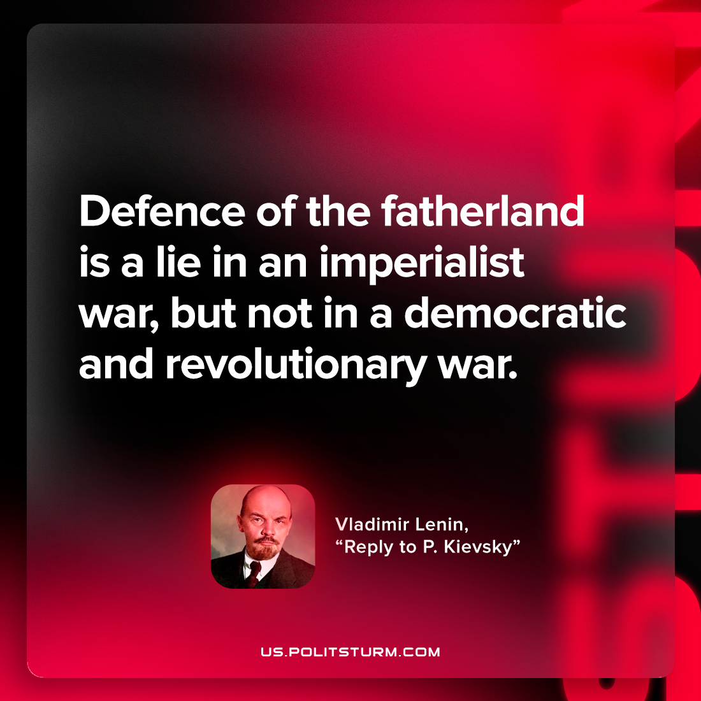

Original article
2023-05-07

"Defence of the fatherland is a lie in an imperialist war, but not in a democratic and revolutionary war."
Vladimir Lenin, “Reply to P. Kievsky (Y. Pyatakov)”

Original article

