Lenin on Imperialism Producing Imperialist Wars
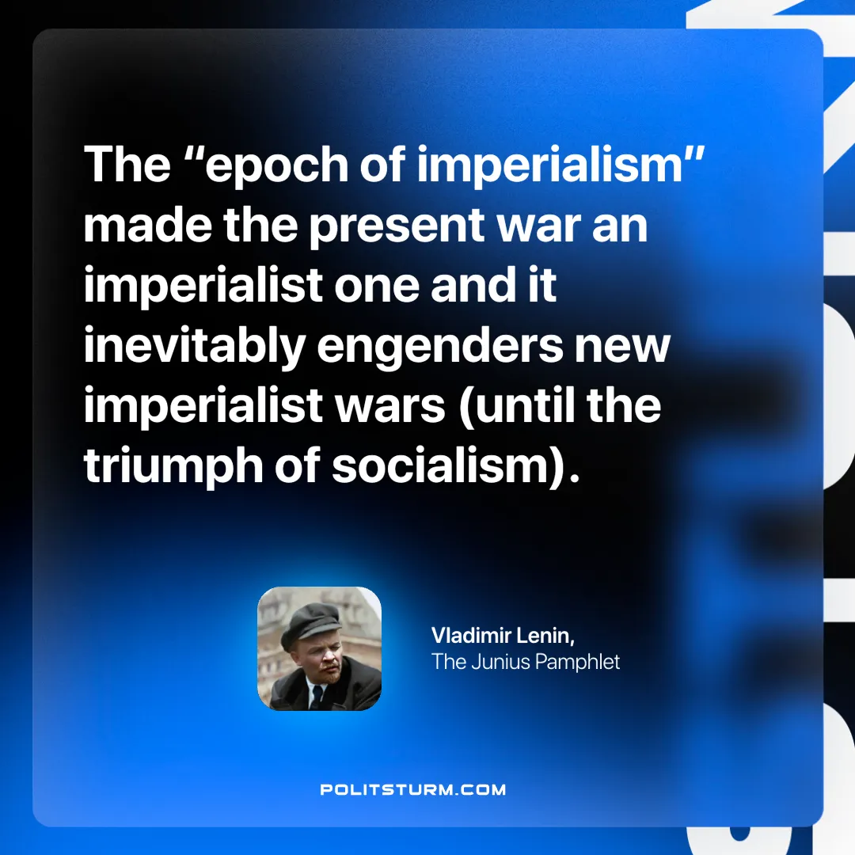

Original article
2025-06-08

“The “epoch of imperialism” made the present war an imperialist one and it inevitably engenders new imperialist wars (until the triumph of socialism).”
Vladimir Lenin, The Junius Pamphlet

Original article

