Lenin on Imperialism as Monopoly Capitalism
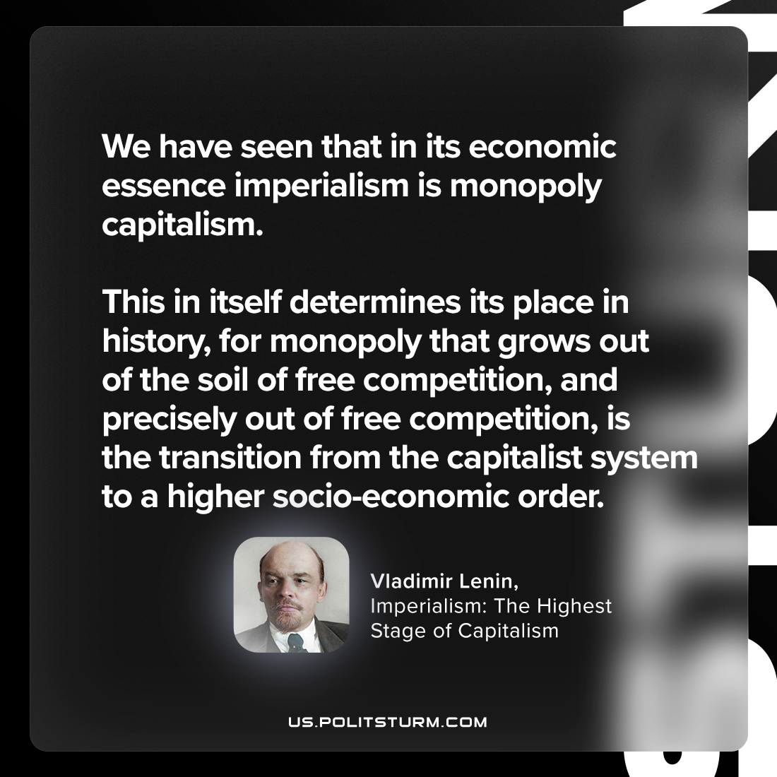

Original article
2024-03-07

"We have seen that in its economic essence imperialism is monopoly capitalism. This in itself determines its place in history, for monopoly that grows out of the soil of free competition, and precisely out of free competition, is the transition from the capitalist system to a higher socio-economic order."
Vladimir Lenin, Imperialism: The Highest Stage of Capitalism

Original article

