Lenin on Imperialism and Socialism
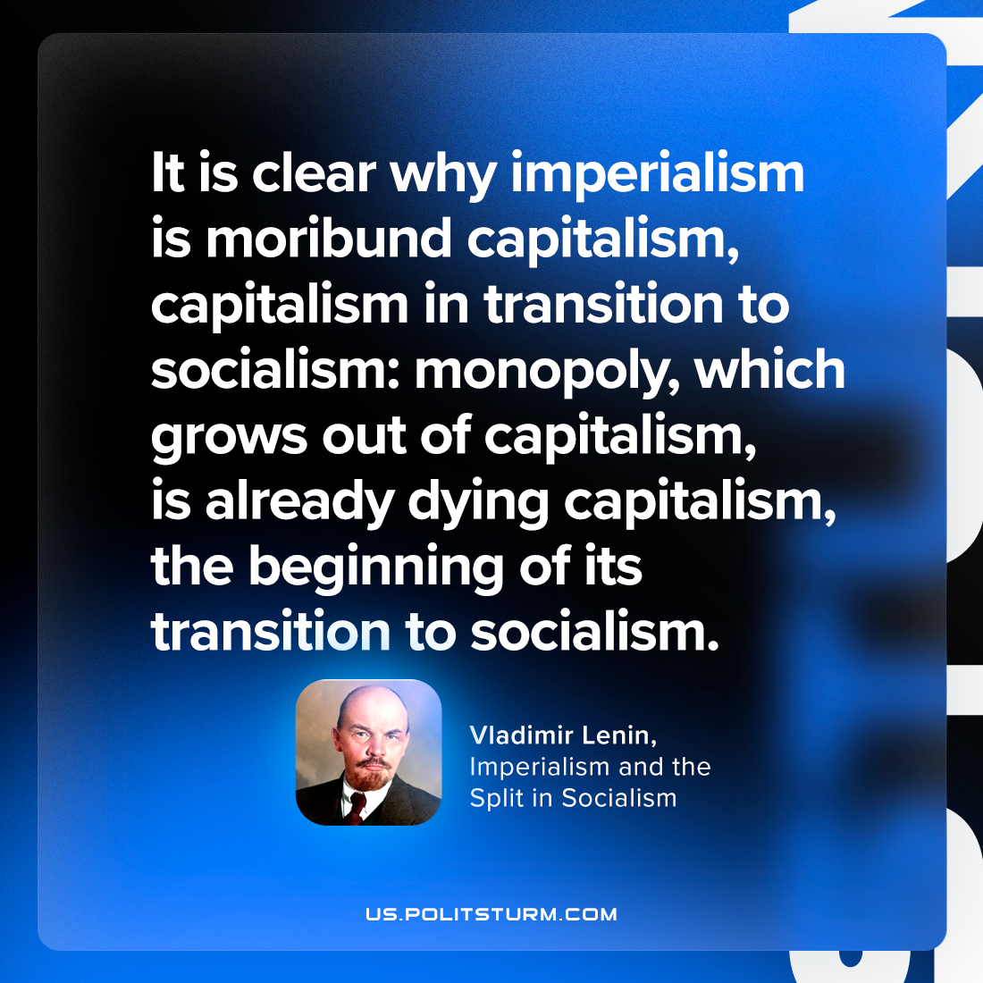

Original article
2023-04-15

"It is clear why imperialism is moribund capitalism, capitalism in transition to socialism: monopoly, which grows out of capitalism, is already dying capitalism, the beginning of its transition to socialism."
Vladimir Lenin, “Imperialism and the Split in Socialism”

Original article

