Lenin on Imperialism and Social-Chauvinism
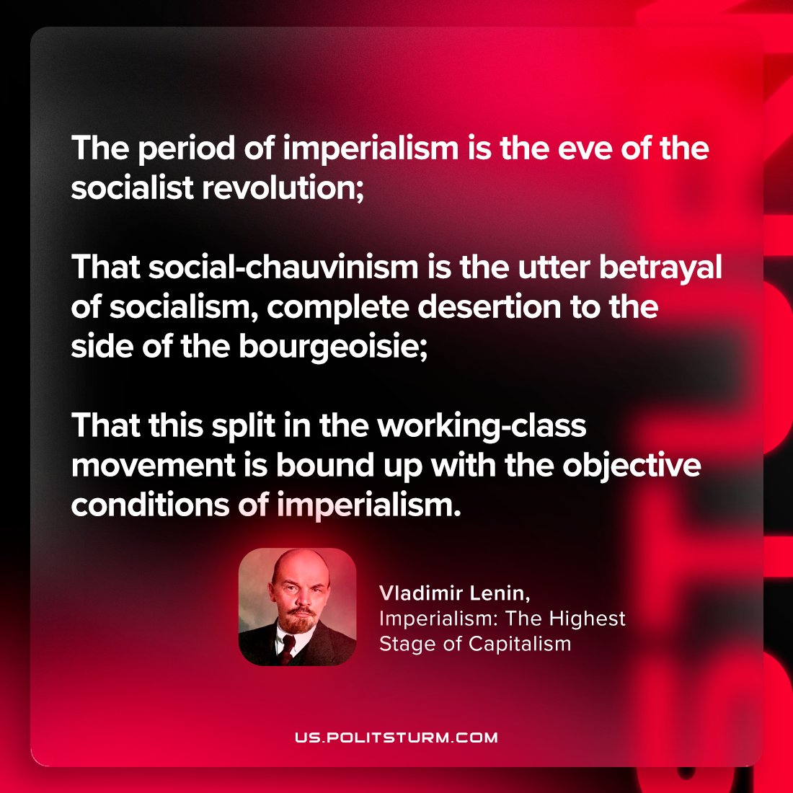

Original article
2023-08-17

"The period of imperialism is the eve of the socialist revolution; that social-chauvinism is the utter betrayal of socialism, complete desertion to the side of the bourgeoisie; that this split in the working-class movement is bound up with the objective conditions of imperialism."
Vladimir Lenin, Imperialism: the Highest Stage of Capitalism

Original article

