Lenin on Imperialism and Nations
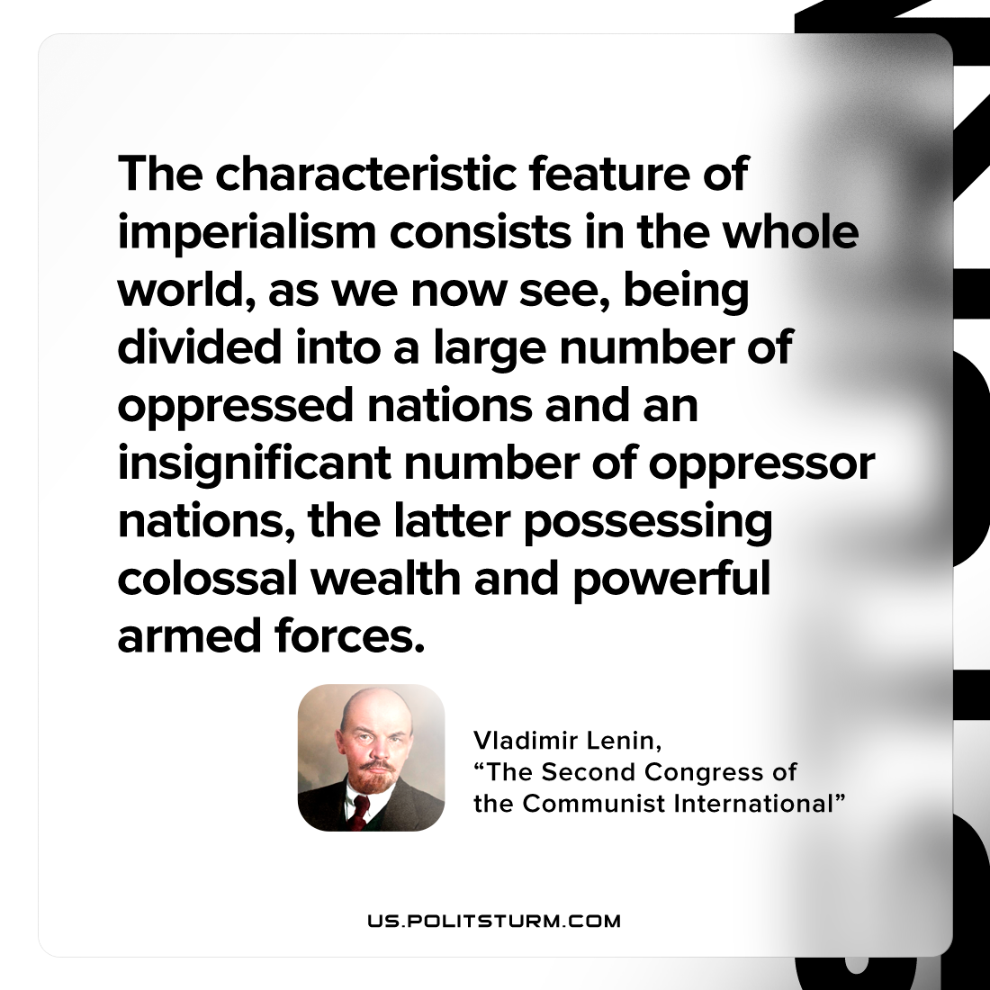

Original article
2023-05-14

"The characteristic feature of imperialism consists in the whole world, as we now see, being divided into a large number of oppressed nations and an insignificant number of oppressor nations, the latter possessing colossal wealth and powerful armed forces."
Vladimir Lenin, “The Second Congress Of The Communist International”

Original article

