Lenin on Imperialism
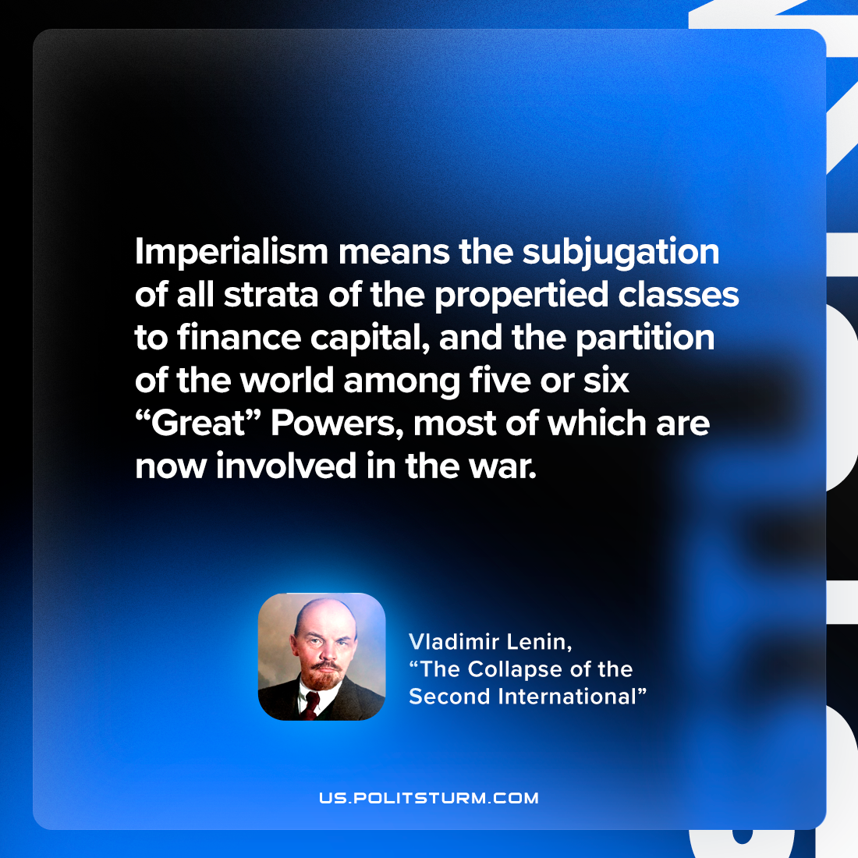

Original article
2022-11-29

"Imperialism means the subjugation of all strata of the propertied classes to finance capital, and the partition of the world among five or six “Great” Powers, most of which are now involved in the war."
Vladimir Lenin, "The Collapse of the Second International"

Original article

