Lenin on Imperialism
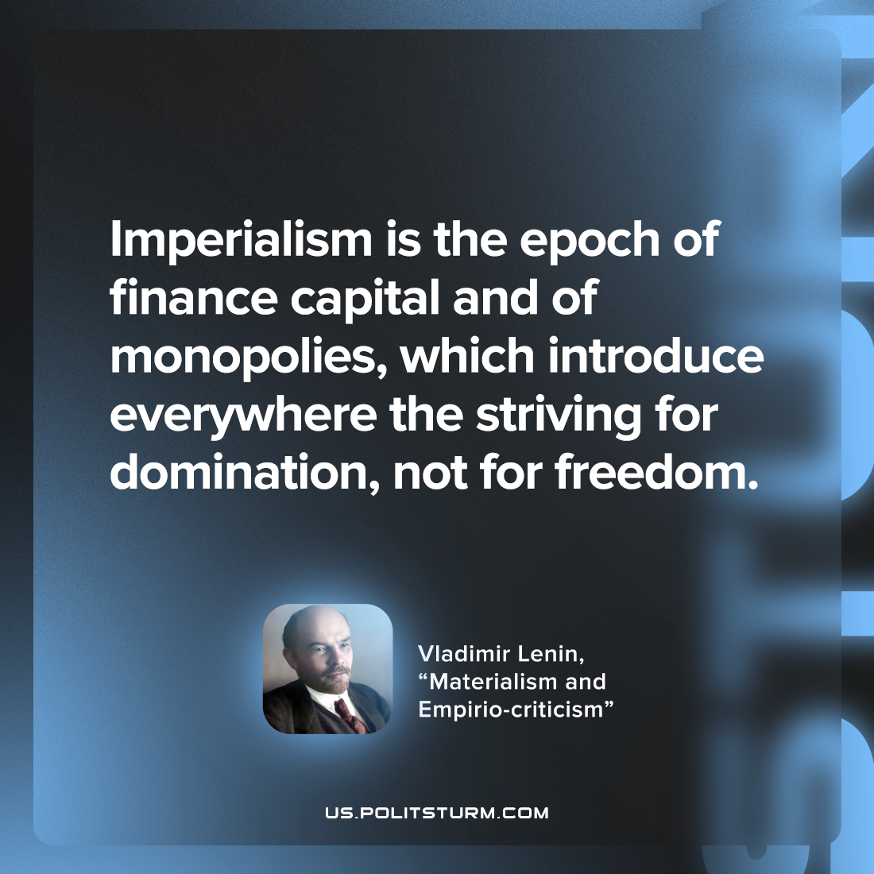

Original article
2022-08-02

Imperialism is the epoch of finance capital and of monopolies, which introduce everywhere the striving for domination, not for freedom.

Vladimir Lenin, “Materialism and empirio-criticism”

Original article

