Lenin on Imperialism
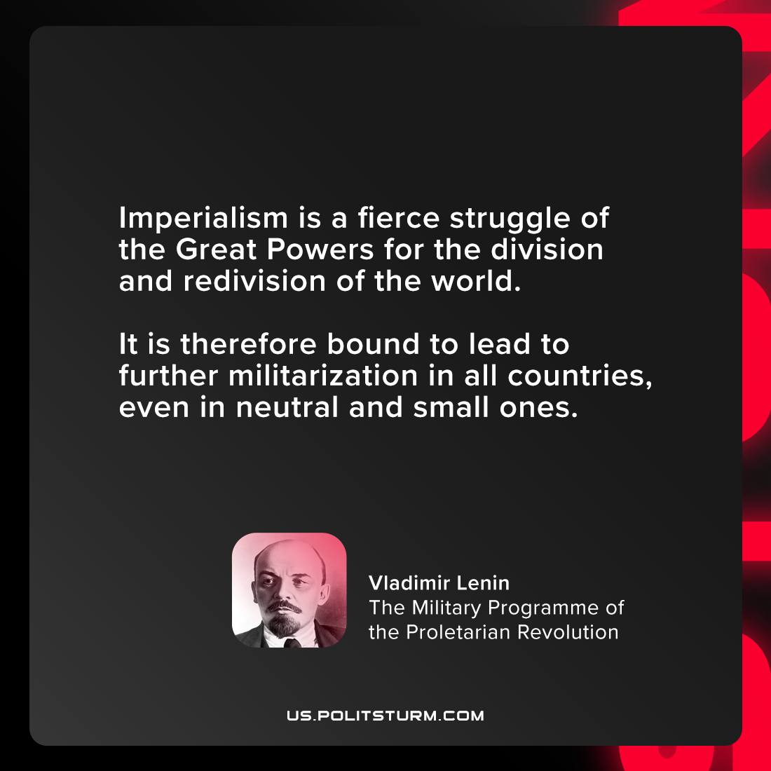

Original article
2021-08-25

Imperialism is a fierce struggle of the Great Powers for the division and redivision of the world. It is therefore bound to lead to further militarization in all countries, even in neutral and small ones.

Vladimir Lenin, “The Military Programme of the Proletarian Revolution”

Original article

