Lenin on Imperialism
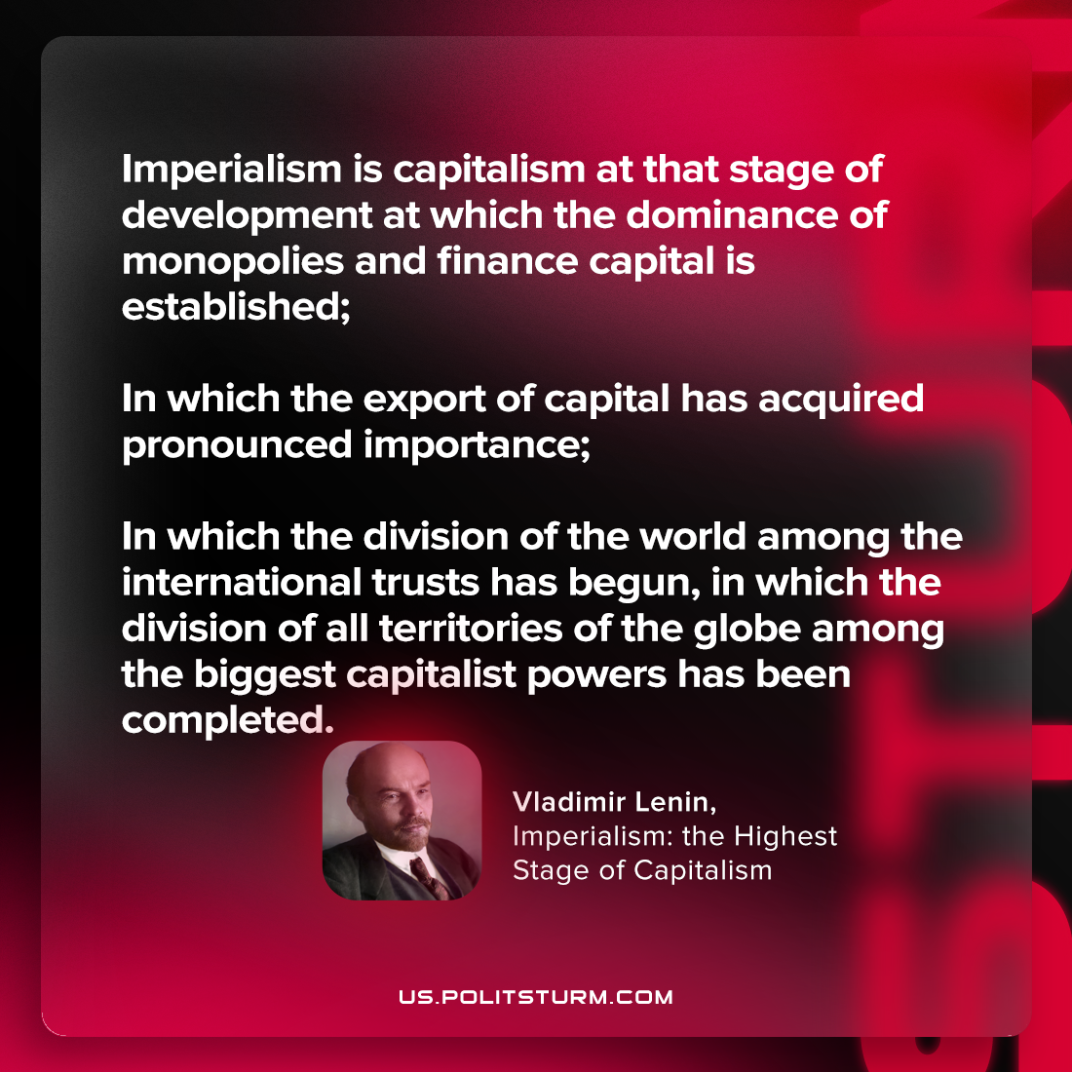

Original article
2023-07-29

"Imperialism is capitalism at that stage of development at which the dominance of monopolies and finance capital is established; in which the export of capital has acquired pronounced importance; in which the division of the world among the international trusts has begun, in which the division of all territories of the globe among the biggest capitalist powers has been completed"
Vladimir Lenin, Imperialism: the Highest Stage of Capitalism

Original article

