Lenin on Ideas
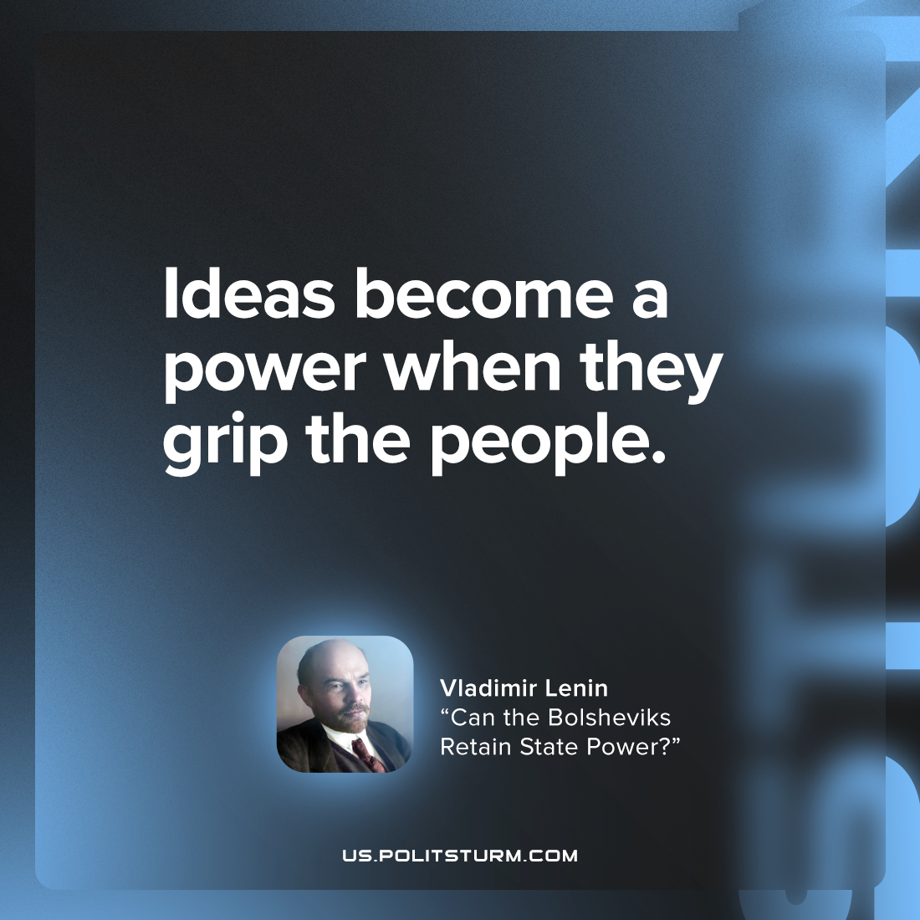

Original article
2022-06-29

Ideas become a power when they grip the people.

Original article

