Lenin on how Opportunists use Radical Ideas to Control the Workers
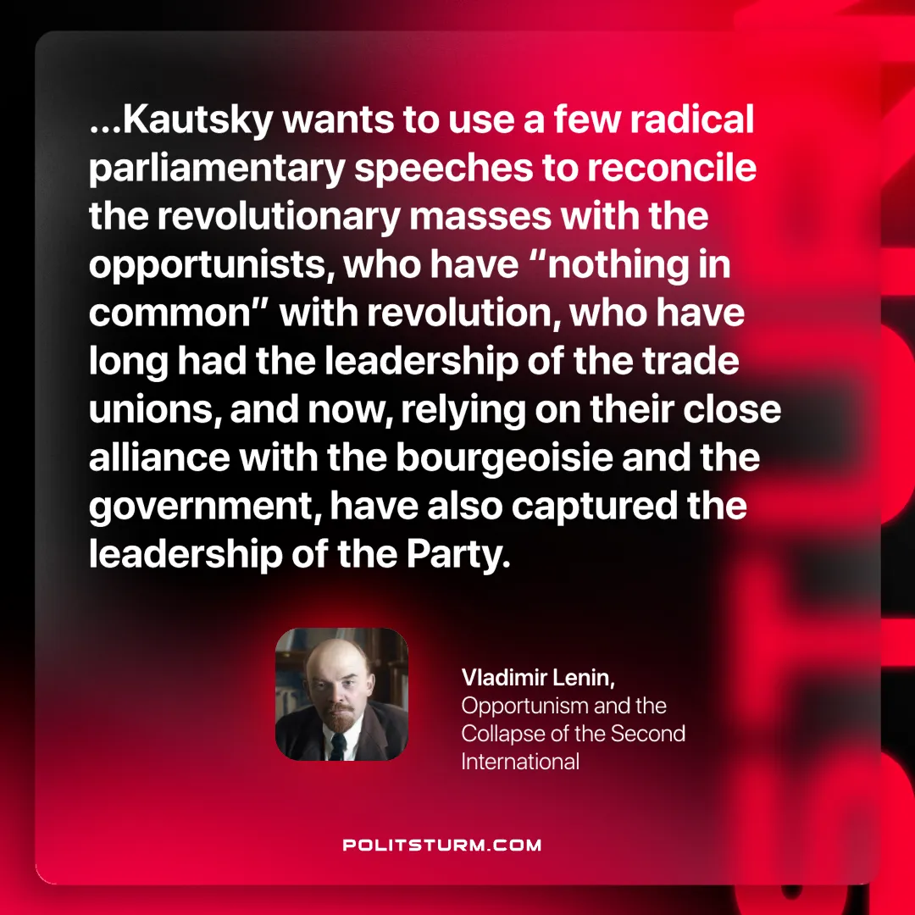

Original article
2025-04-22

“...Kautsky wants to use a few radical parliamentary speeches to reconcile the revolutionary masses with the opportunists, who have “nothing in common” with revolution, who have long had the leadership of the trade unions, and now, relying on their close alliance with the bourgeoisie and the government, have also captured the leadership of the Party.”
Vladimir Lenin, Opportunism and the Collapse of the Second International

Original article

