Lenin on Freedom
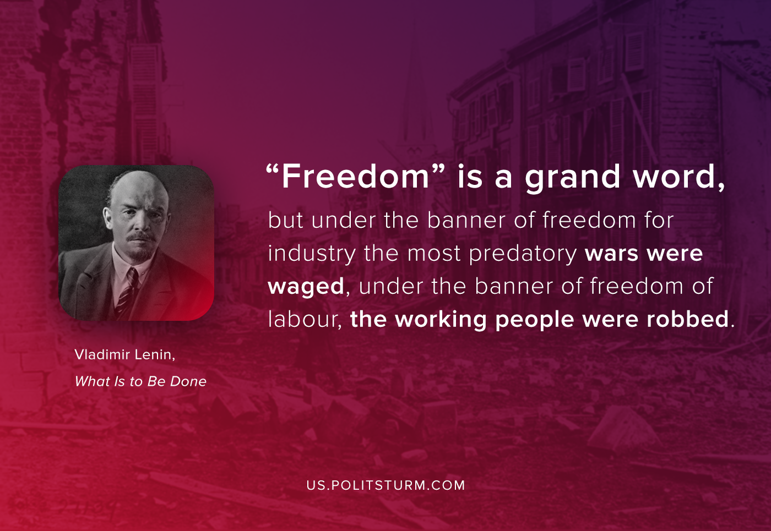

Original article
2020-09-10

“Freedom” is a grand word, but under the banner of freedom for industry the most predatory wars were waged, under the banner of freedom of labour the working people were robbed.
Vladimir Lenin, “What Is To Be Done”

Original article

