Lenin on Freedom under Capitalism
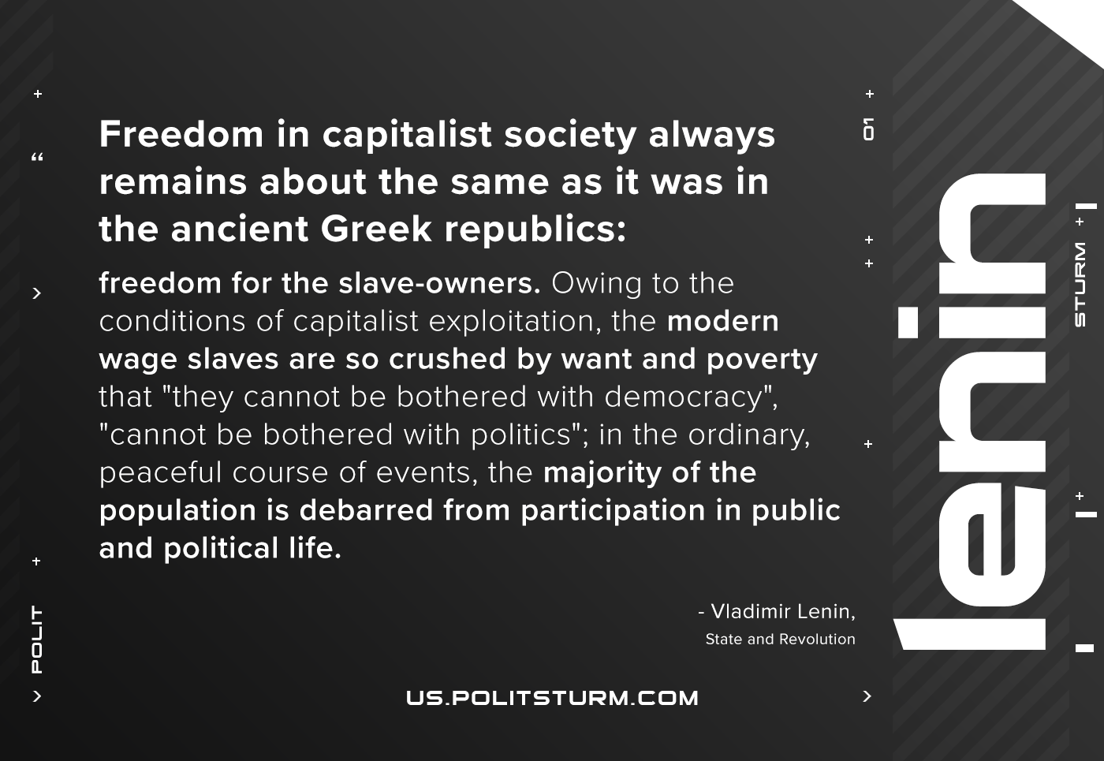

Original article
2021-02-28

Freedom in capitalist society always remains about the same as it was in the ancient Greek republics: freedom for the slave-owners. Owing to the conditions of capitalist exploitation, the modern wage slaves are so crushed by want and poverty that “they cannot be bothered with democracy”, “cannot be bothered with politics”; in the ordinary, peaceful course of events, the majority of the population is debarred from participation in public and political life.
Lenin, State and Revolution

Original article

