Lenin on Financial Oligarchy
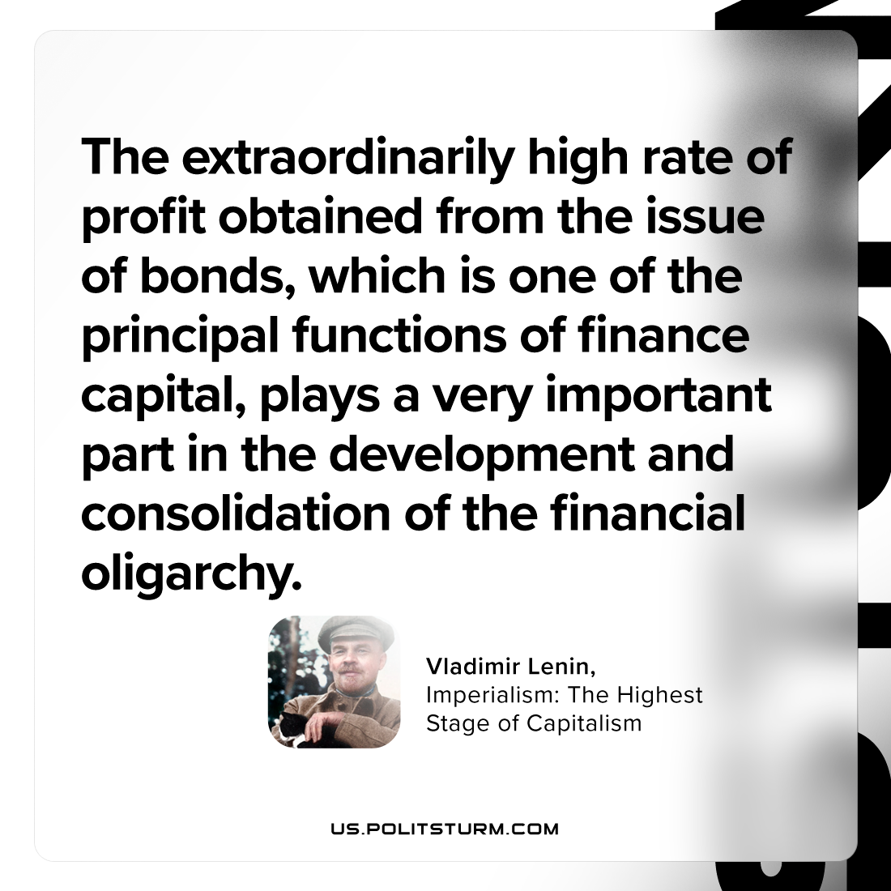

Original article
2023-09-30

"The extraordinarily high rate of profit obtained from the issue of bonds, which is one of the principal functions of finance capital, plays a very important part in the development and consolidation of the financial oligarchy."
Vladimir Lenin, Imperialism: the Highest Stage of Capitalism

Original article

