Lenin on Finance Capital
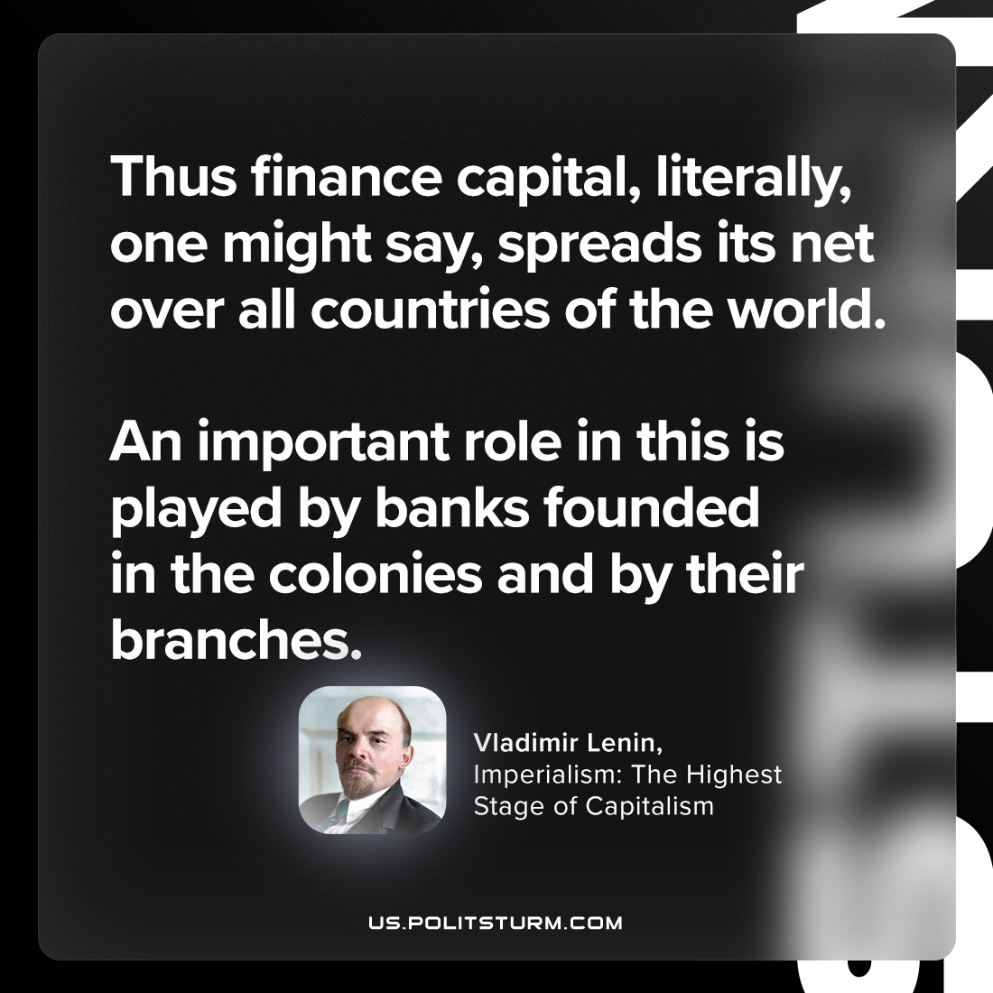

Original article
2023-10-14

"Thus finance capital, literally, one might say, spreads its net over all countries of the world. An important role in this is played by banks founded in the colonies and by their branches."
Vladimir Lenin, Imperialism: the Highest Stage of Capitalism

Original article

