Lenin on fighting opportunism
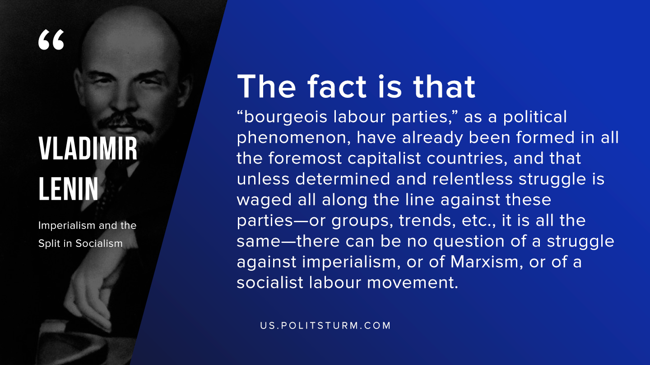

Original article
2020-02-10

The fact that is that “bourgeois labour parties,” as a political phenomenon, have already been formed in all the foremost capitalist countries, and that unless determined and relentless struggle is waged all along the line against these parties—or groups, trends, etc., it is all the same—there can be no question of a struggle against imperialism, or of Marxism, or of a socialist labour movement.
V.I. Lenin, “Imperialism and the Split in Socialism”

Original article

