Lenin on Expropriating and Class Struggle
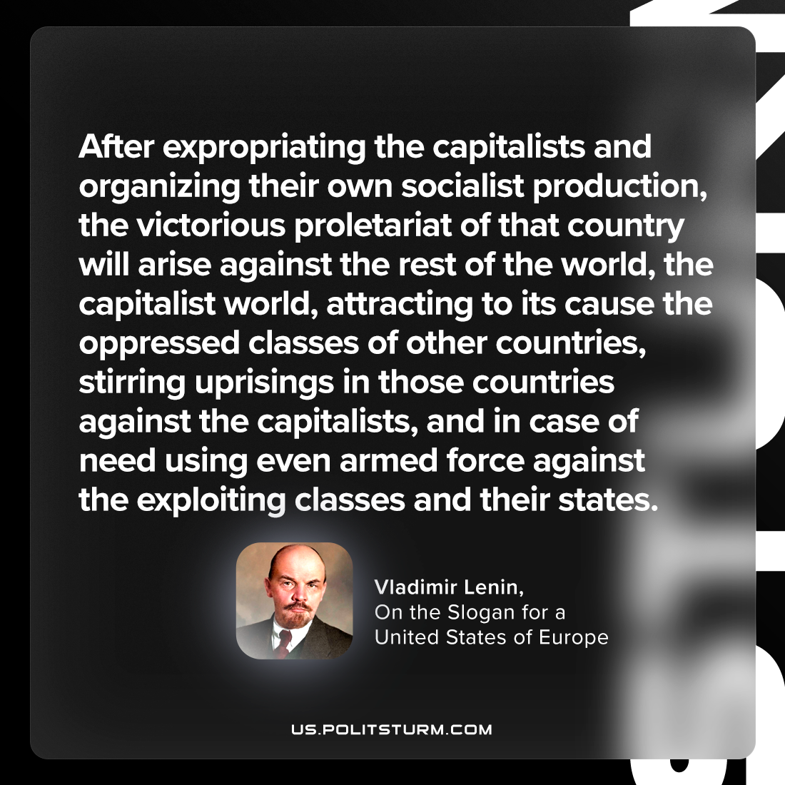

Original article
2023-08-06

"After expropriating the capitalists and organizing their own socialist production, the victorious proletariat of that country will arise against the rest of the world—the capitalist world—attracting to its cause the oppressed classes of other countries, stirring uprisings in those countries against the capitalists, and in case of need using even armed force against the exploiting classes and their states."
Vladimir Lenin, On the Slogan for a United States of Europe

Original article

