Lenin on Export of Goods and Export of Capital
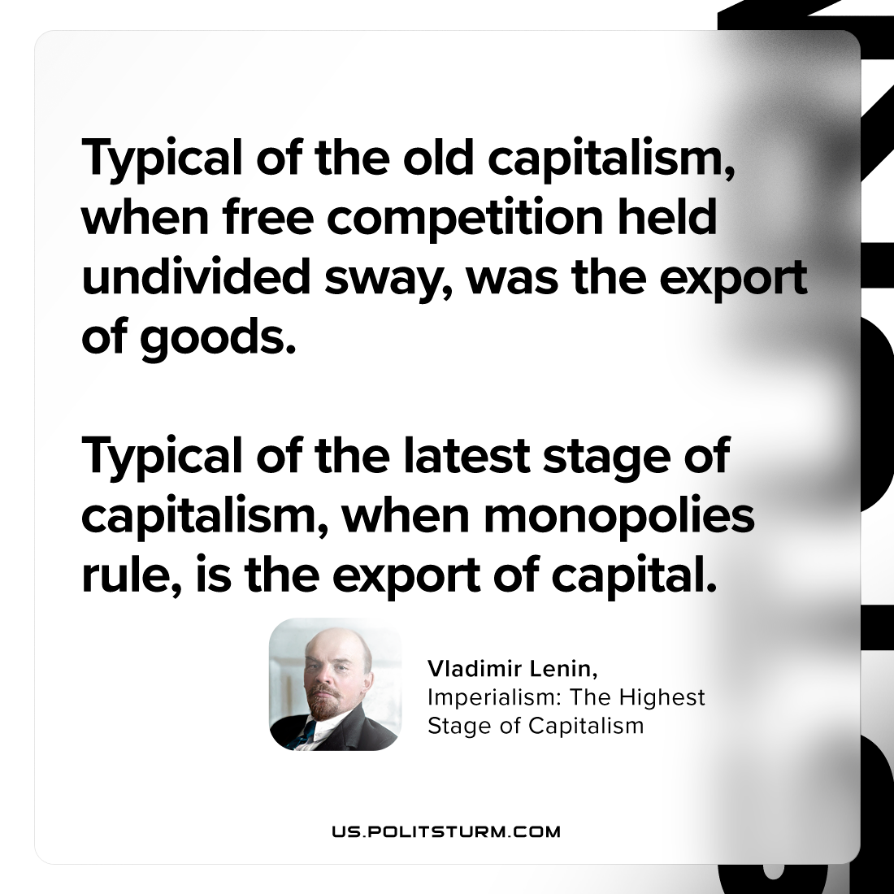

Original article
2023-09-17

"Typical of the old capitalism, when free competition held undivided sway, was the export of goods. Typical of the latest stage of capitalism, when monopolies rule, is the export of capital."
Vladimir Lenin, Imperialism: the Highest Stage of Capitalism

Original article

