Lenin on Exploitation
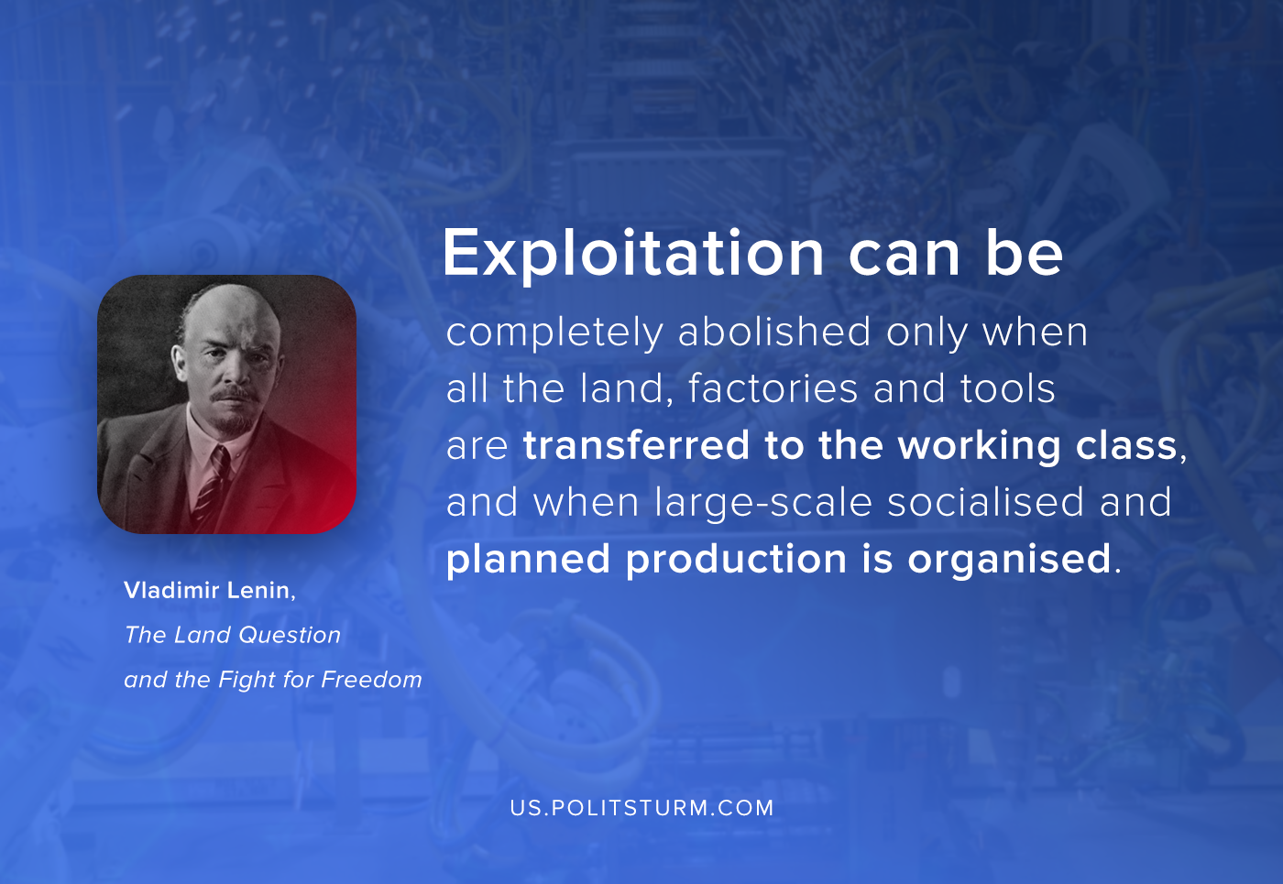

Original article
2020-09-12

Exploitation can be completely abolished only when all the land, factories and tools are transferred to the working class, and when large-scale socialized and planned production is organized.
Vladimir Lenin, The Land Question and The Fight for Freedom

Original article

