Lenin on Era of Imperialist Wars
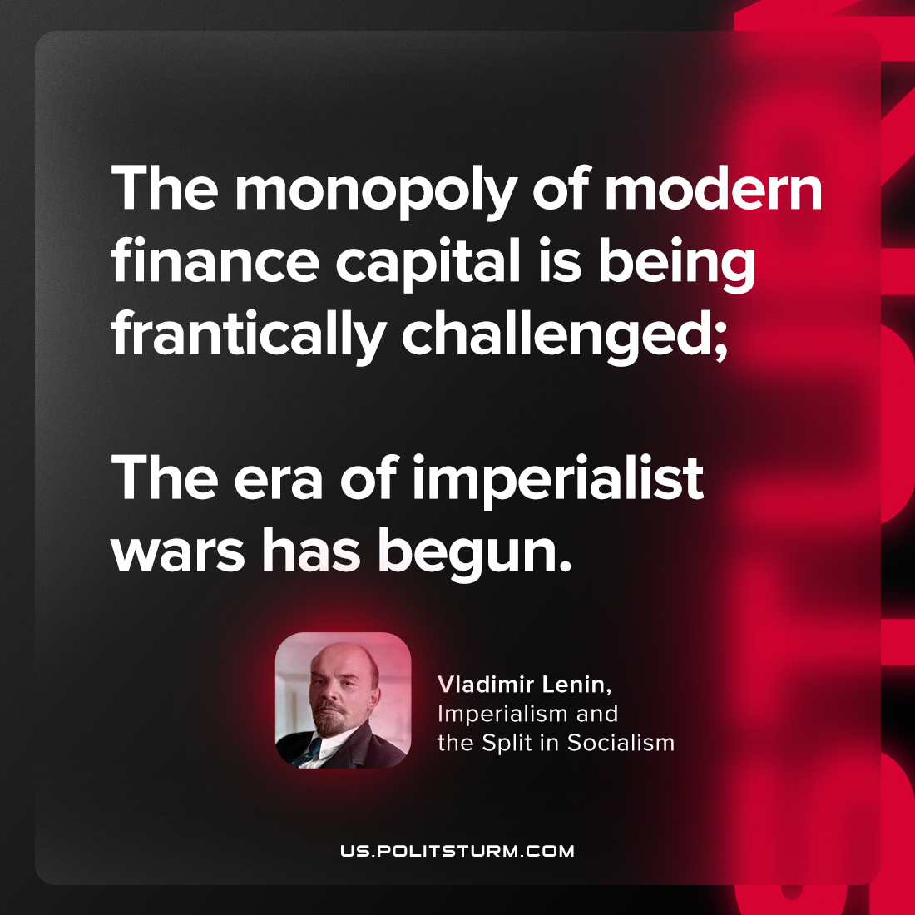

Original article
2023-06-03

"The monopoly of modern finance capital is being frantically challenged; the era of imperialist wars has begun."
Vladimir Lenin, “Imperialism and the Split in Socialism”

Original article

