Lenin on Equality
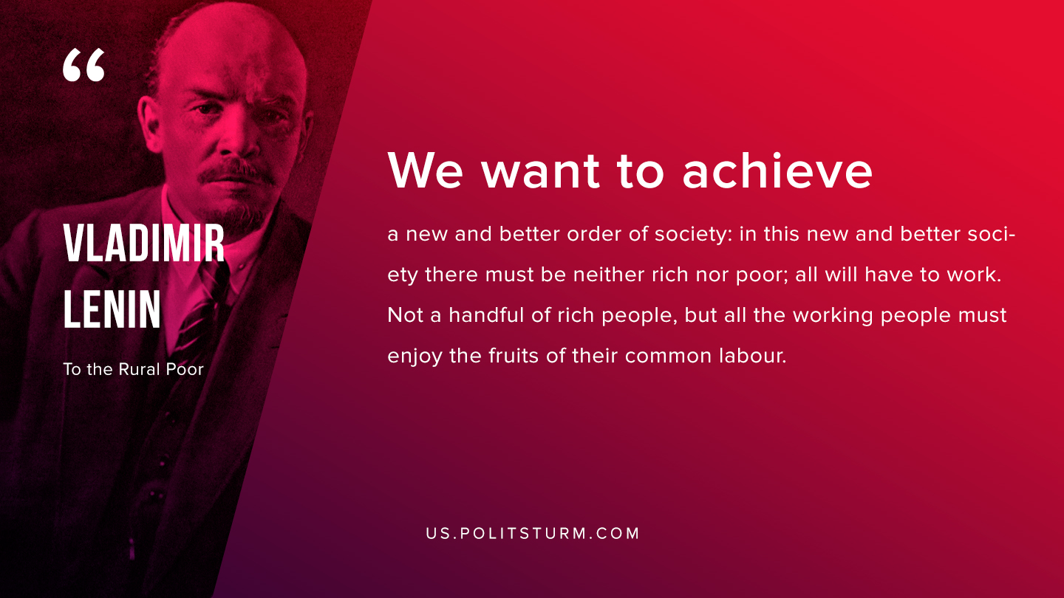

Original article
2019-08-01

We want to achieve a new and better order of society: in this new and better society there must be neither rich nor poor; all will have to work. Not a handful of rich people, but all the working people must enjoy the fruits of their common labour.
V.I. Lenin “To the Rural Poor”

Original article

