Lenin on Equality
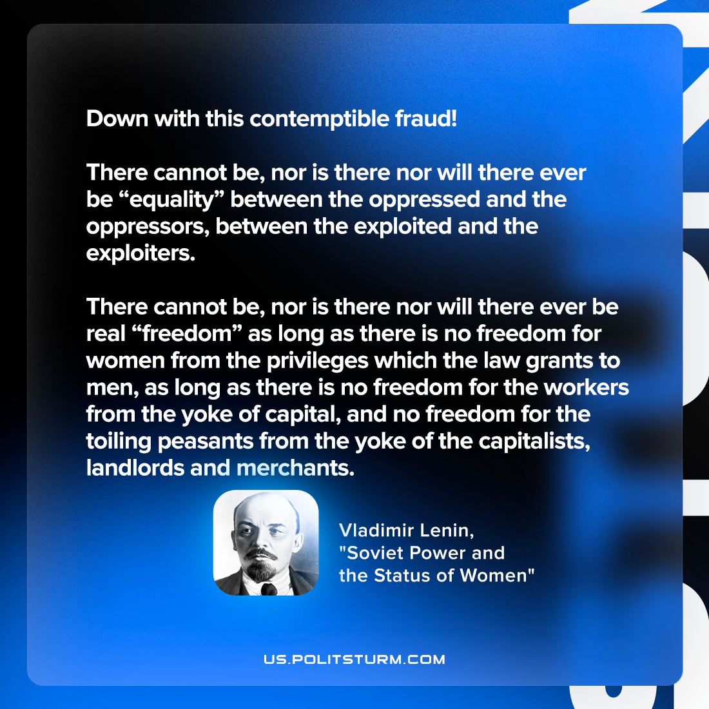

Original article
2022-05-26
1 min read

Down with this contemptible fraud! There cannot be, nor is there nor will there ever be “equality” between the oppressed and the oppressors, between the exploited and the exploiters. There cannot be, nor is there nor will there ever be real “freedom” as long as there is no freedom for women from the privileges which the law grants to men, as long as there is no freedom for the workers from the yoke of capital, and no freedom for the toiling peasants from the yoke of the capitalists, landlords and merchants.

Vladimir Lenin, “Soviet Power and the Status of Women”

Original article

