Lenin on Epoch of Violence and War
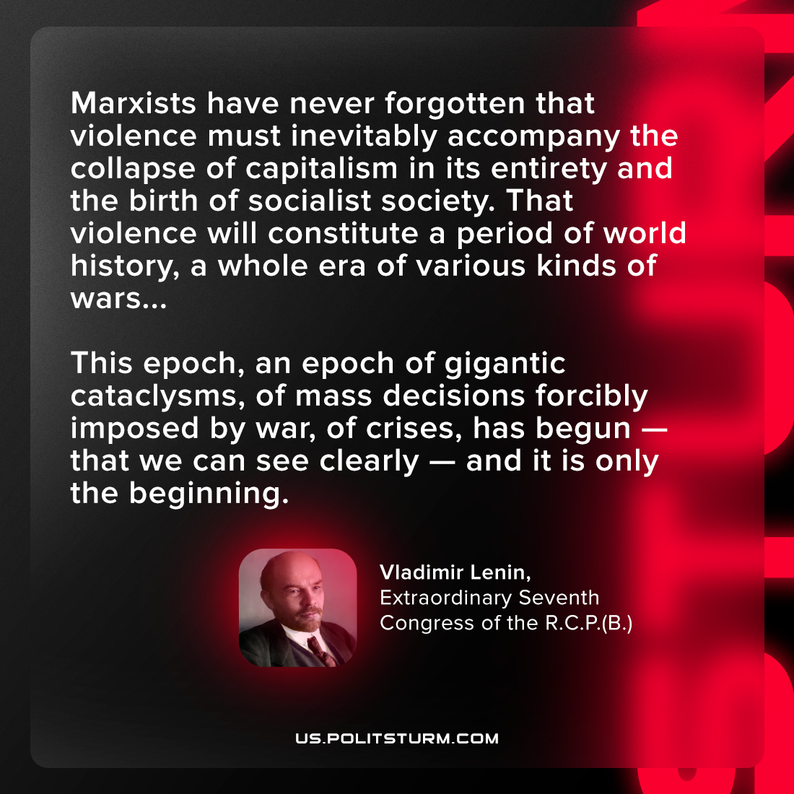

Original article
2023-01-17

"Marxists have never forgotten that violence must inevitably accompany the collapse of capitalism in its entirety and the birth of socialist society. That violence will constitute a period of world history, a whole era of various kinds of wars...This epoch, an epoch of gigantic cataclysms, of mass decisions forcibly imposed by war, of crises, has begun—that we can see clearly—and it is only the beginning."
Vladimir Lenin, Extraordinary Seventh Congress of the R.C.P.(B.)

Original article

