Lenin on Elections
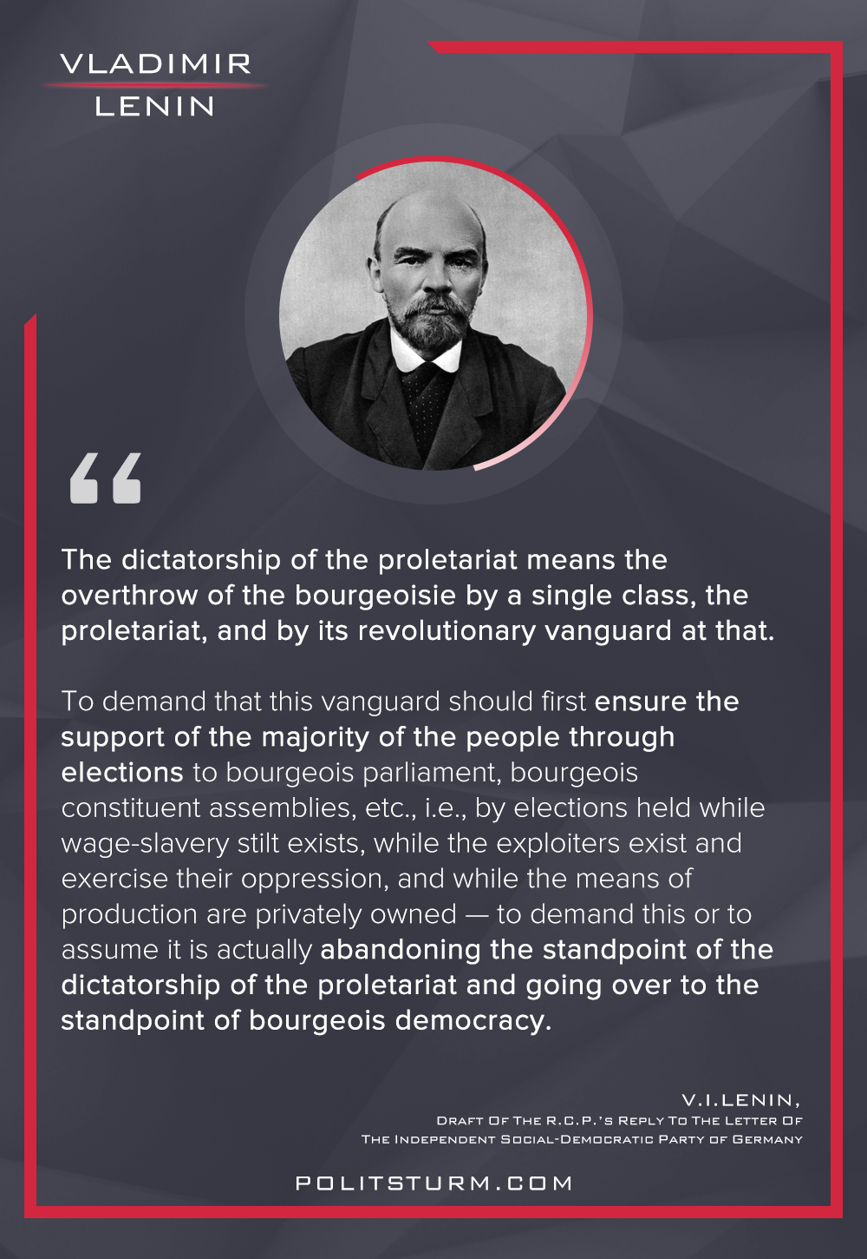

Original article
2022-09-02
1 min read

“…5. The dictatorship of the proletariat means the overthrow of the bourgeoisie by a single class, the proletariat, and by its revolutionary vanguard at that. To demand that this vanguard should first ensure the support of the majority of the people through elections to bourgeois parliament, bourgeois constituent assemblies, etc., i.e., by elections held while wage-slavery stilt exists, while the exploiters exist and exercise their oppression, and while the means of production are privately owned — to demand this or to assume it is actually abandoning the standpoint of the dictatorship of the proletariat and going over to the standpoint of bourgeois democracy.”
Vladimir Lenin, “Draft (Or Theses) Of The R.C.P.’s Reply To The Letter Of The Independent Social-Democratic Party of Germany “.

Original article

