Lenin on Elections
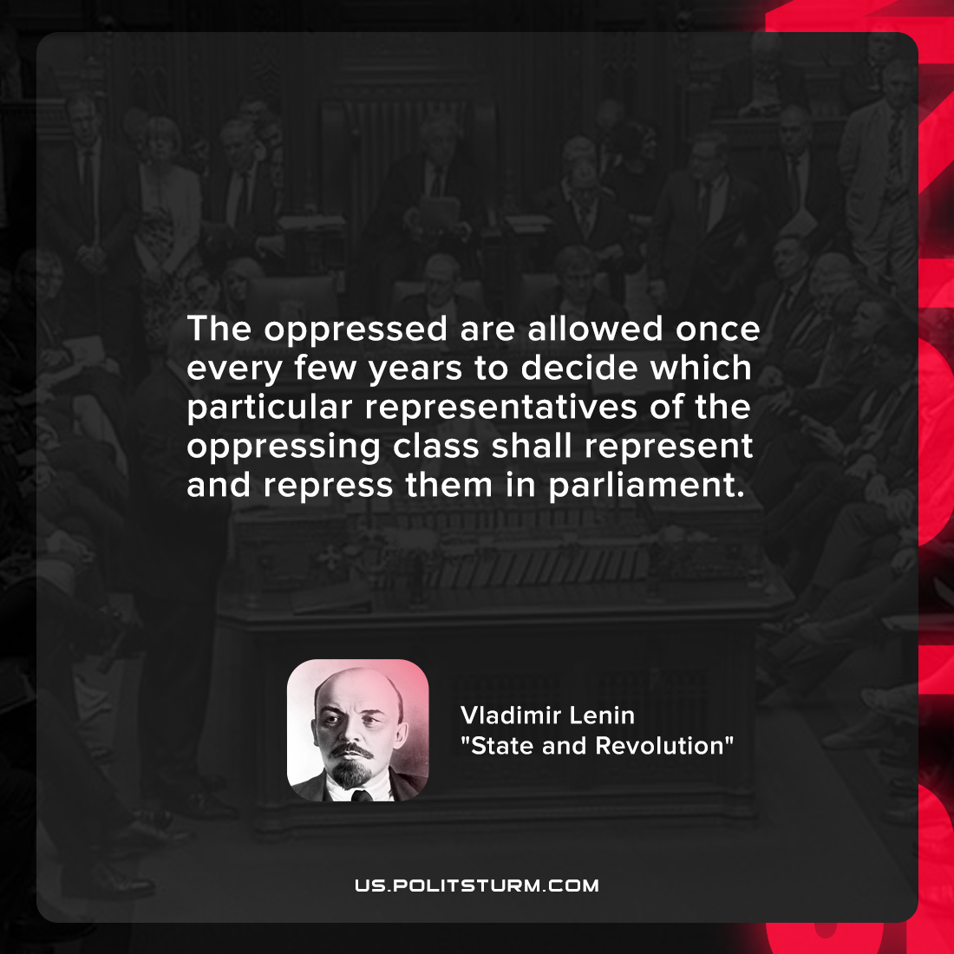

Original article
2022-03-16

The oppressed are allowed once every few years to decide which particular representatives of the oppressing class shall represent and repress them in parliament.

Vladimir Lenin, “State and Revolution”

Original article

