Lenin on Division Under Capitalism
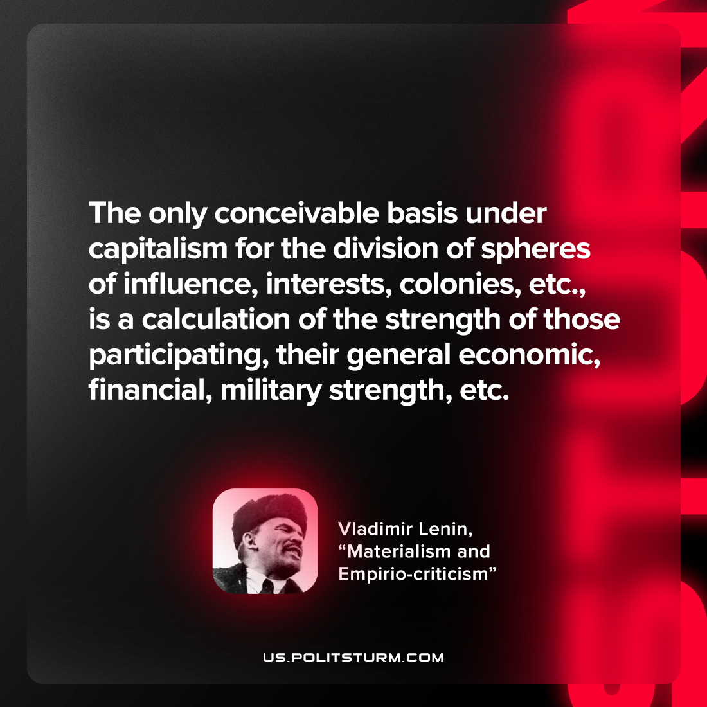

Original article
2022-08-06

The only conceivable basis under capitalism for the division of spheres of influence, interests, colonies, etc., is a calculation of the strength of those participating, their general economic, financial, military strength, etc.

Vladimir Lenin, “Materialism and empirio-criticism”

Original article

