Lenin on Distortions of Marx for Nationalist Ends
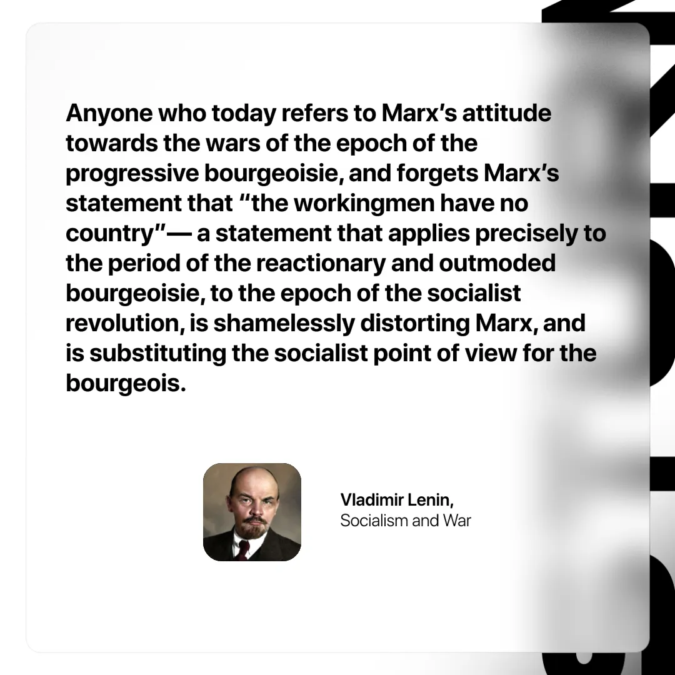

Original article
2025-04-12

“Anyone who today refers to Marx’s attitude towards the wars of the epoch of the progressive bourgeoisie, and forgets Marx’s statement that “the workingmen have no country”— a statement that applies precisely to the period of the reactionary and outmoded bourgeoisie, to the epoch of the socialist revolution, is shamelessly distorting Marx, and is substituting the socialist point of view for the bourgeois.”
Vladimir Lenin, Socialism and War

Original article

