Lenin on Dispelling Religious Prejudice
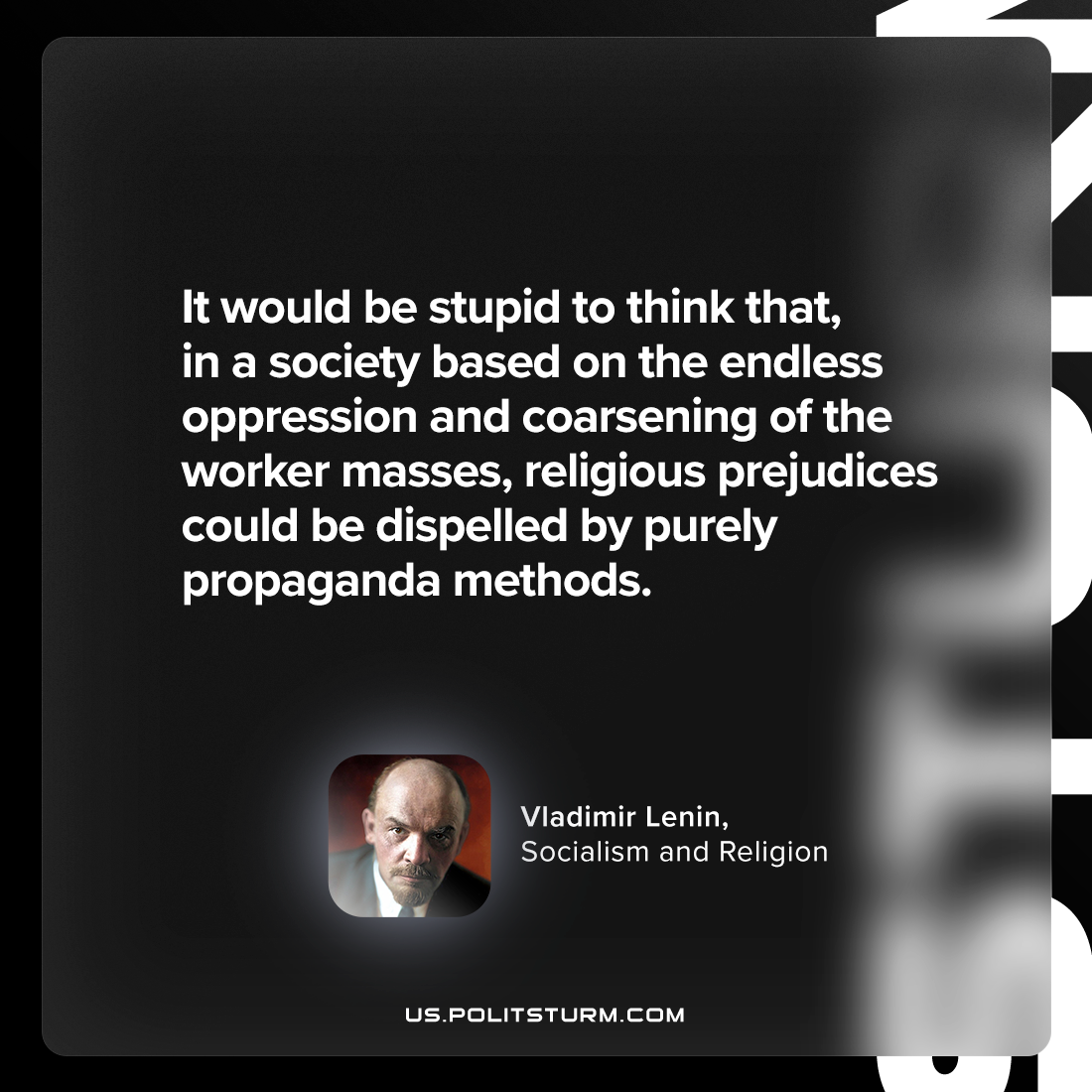

Original article
2024-05-21

"It would be stupid to think that, in a society based on the endless oppression and coarsening of the worker masses, religious prejudices could be dispelled by purely propaganda methods."
Vladimir Lenin, Socialism and Religion

Original article

