Lenin on Disarmament
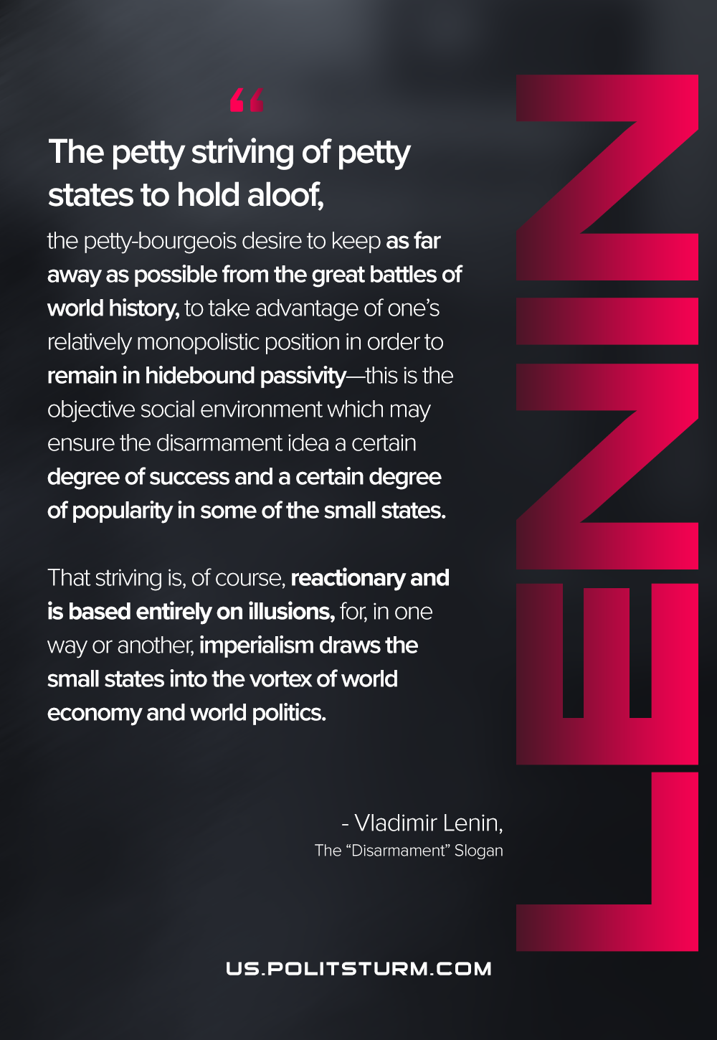

Original article
2021-03-01
1 min read

The petty striving of petty states to hold aloof, the petty-bourgeois desire to keep as far away as possible from the great battles of world history, to take advantage of one’s relatively monopolistic position in order to remain in hidebound passivity—this is the objective social environment which may ensure the disarmament idea a certain degree of success and a certain degree of popularity in some of the small states. That striving is, of course, reactionary and is based entirely on illusions, for, in one way or another, imperialism draws the small states into the vortex of world economy and world politics.
Lenin, The “Disarmament” Slogan

Original article

