Lenin on Disarmament
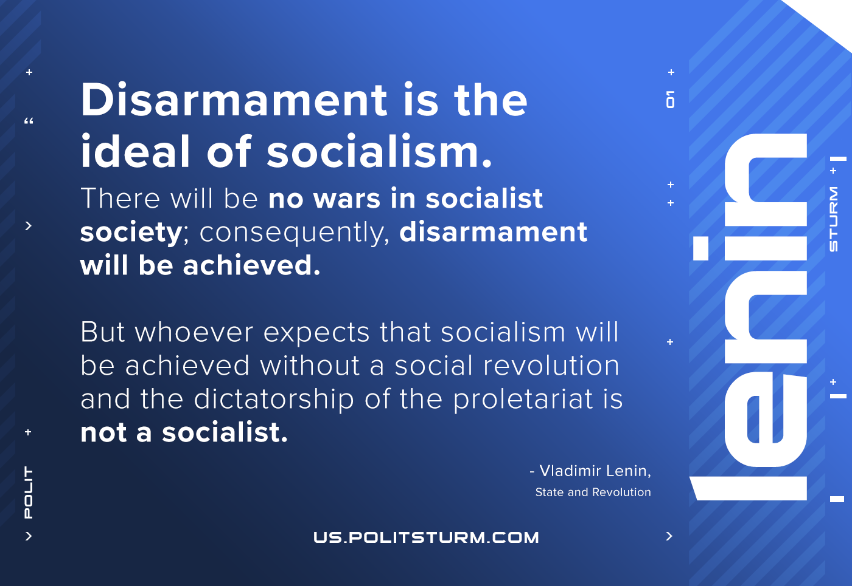

Original article
2021-05-23

Disarmament is the ideal of socialism. There will be no wars in socialist society; consequently, disarmament will be achieved But whoever expects that socialism will be achieved without a social revolution and the dictatorship of the proletariat is not a socialist.
Lenin, The “Disarmament” Slogan

Original article

