Lenin on Dictatorship of the Proletariat
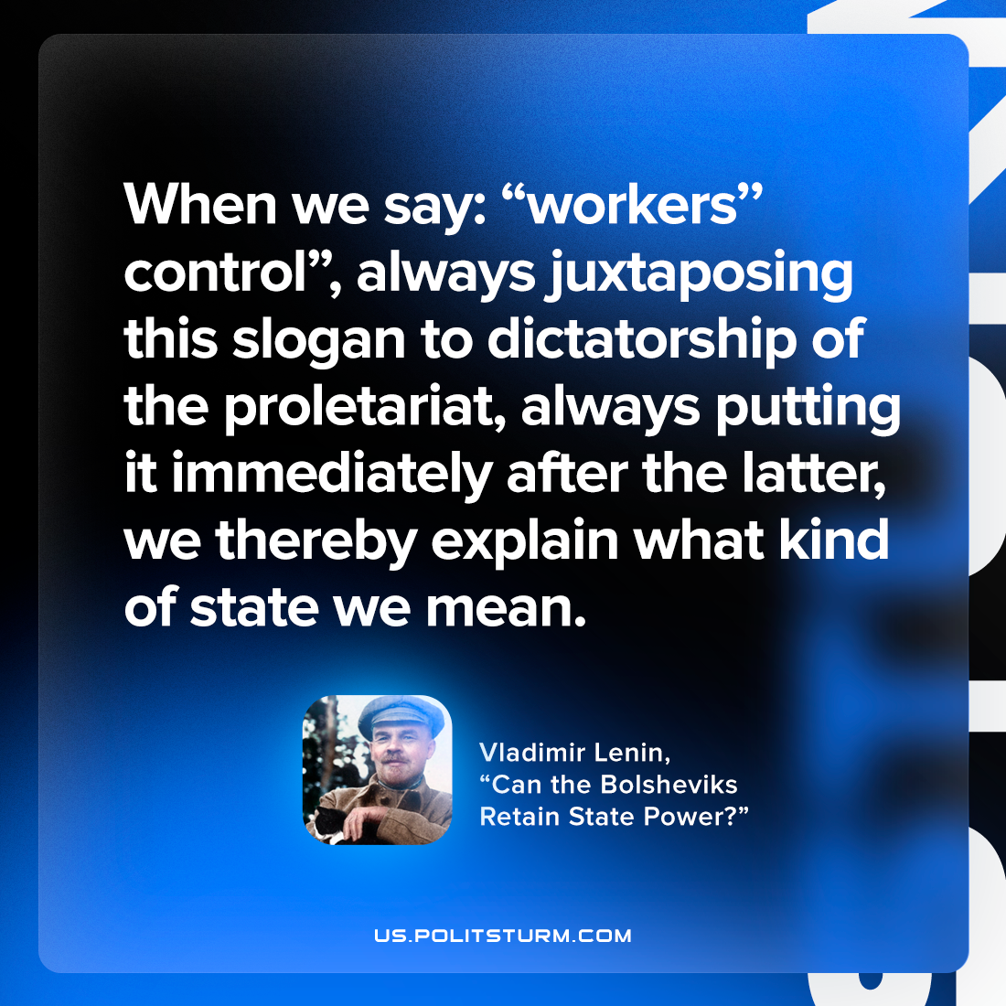

Original article
2023-05-18

"When we say: “workers’ control”, always juxtaposing this slogan to dictatorship of the proletariat, always putting it immediately after the latter, we thereby explain what kind of state we mean."
Vladimir Lenin, “Can the Bolsheviks Retain State Power?”

Original article

