Lenin on Democracy
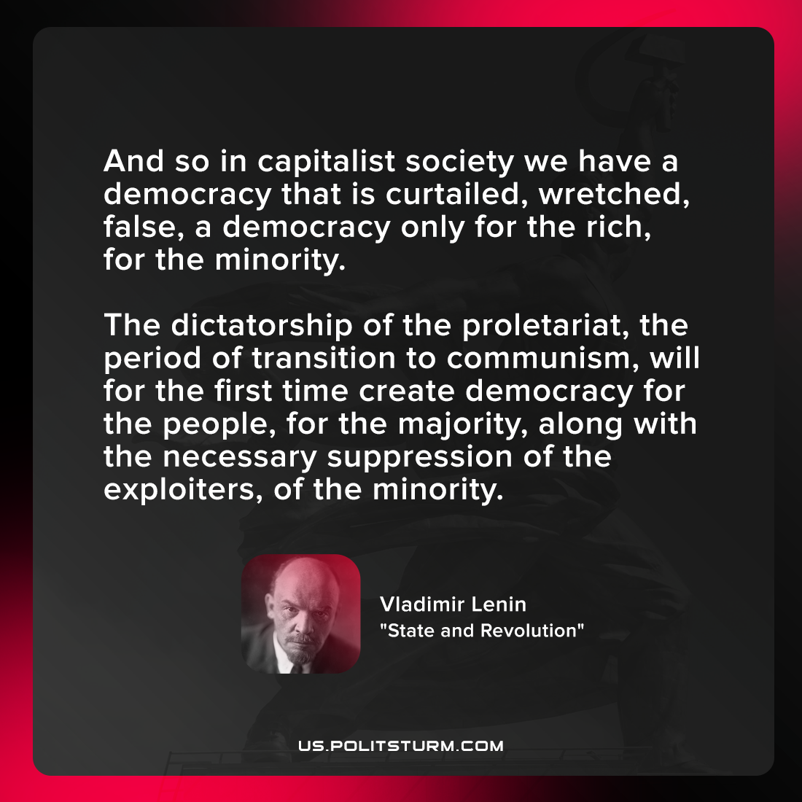

Original article
2021-10-18

And so in capitalist society we have a democracy that is curtailed, wretched, false, a democracy only for the rich, for the minority. The dictatorship of the proletariat, the period of transition to communism, will for the first time create democracy for the people, for the majority, along with the necessary suppression of the exploiters, of the minority.

Vladimir Lenin, “State and Revolution”

Original article

