Lenin on Constitutions
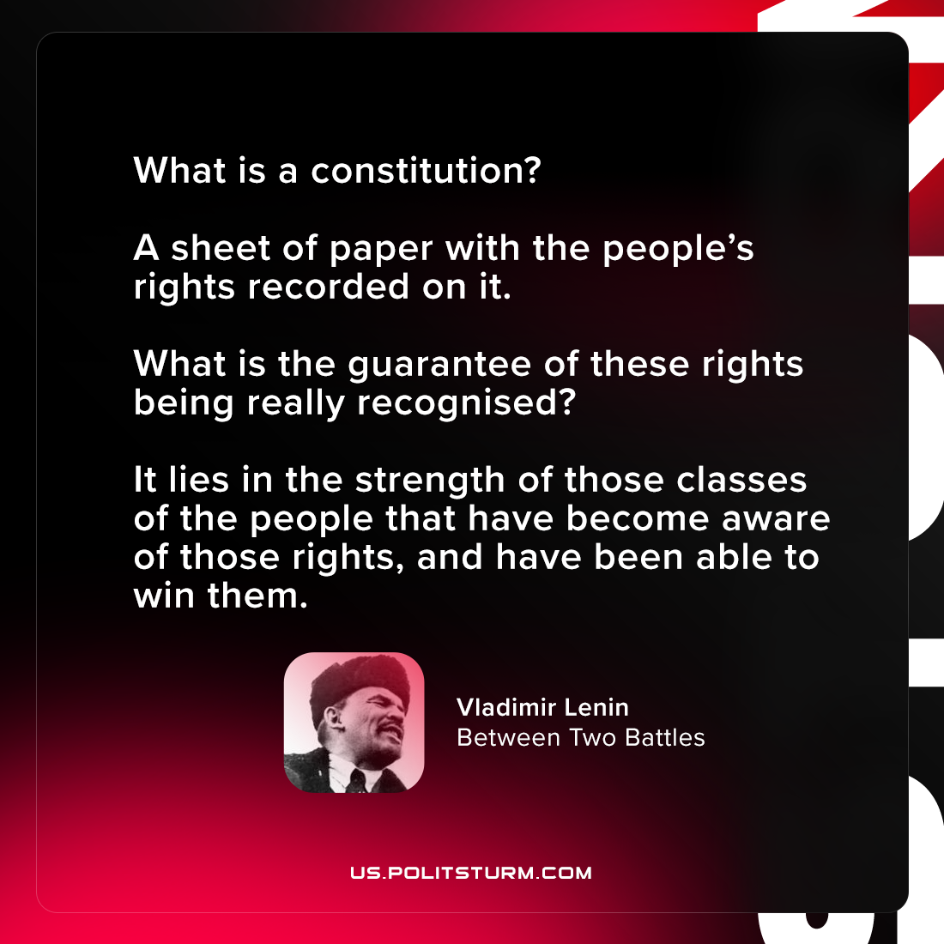

Original article
2021-09-02

What is a constitution? A sheet of paper with the people’s rights recorded on it. What is the guarantee of these rights being really recognised? It lies in the strength of those classes of the people that have become aware of those rights, and have been able to win them.

Vladimir Lenin, “Between Two Battles”

Original article

