Lenin on Class Struggle and Terror
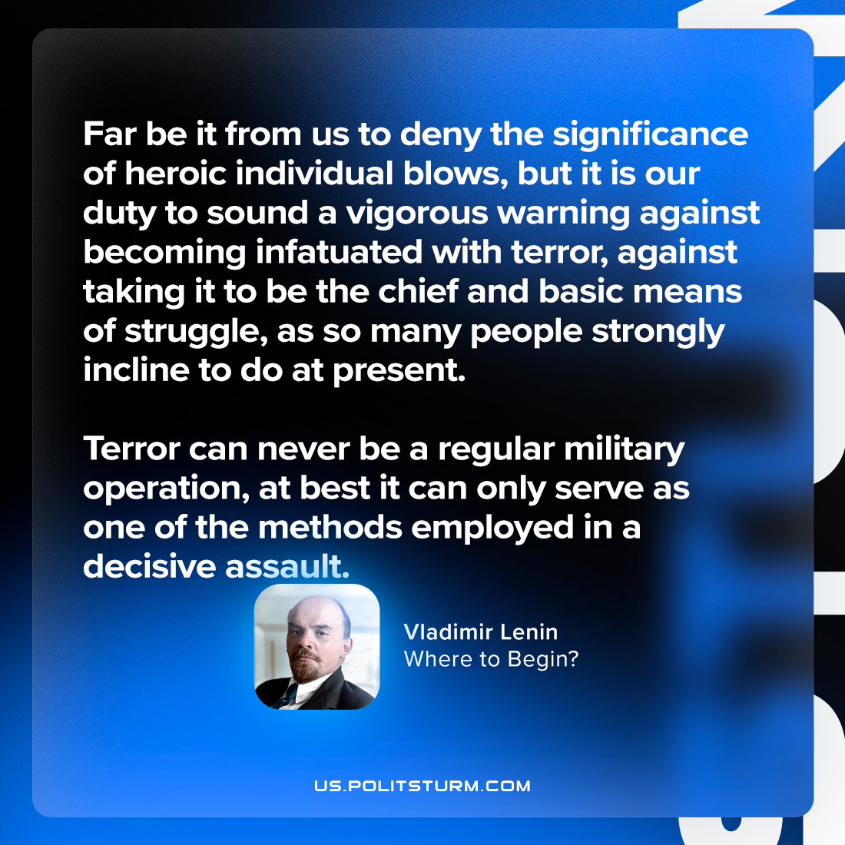

Original article
2024-04-28

“Far be it from us to deny the significance of heroic individual blows, but it is our duty to sound a vigorous warning against becoming infatuated with terror, against taking it to be the chief and basic means of struggle, as so many people strongly incline to do at present. Terror can never be a regular military operation; at best it can only serve as one of the methods employed in a decisive assault.”
Vladimir Lenin, Where to Begin?

Original article

