Lenin on Class Struggle
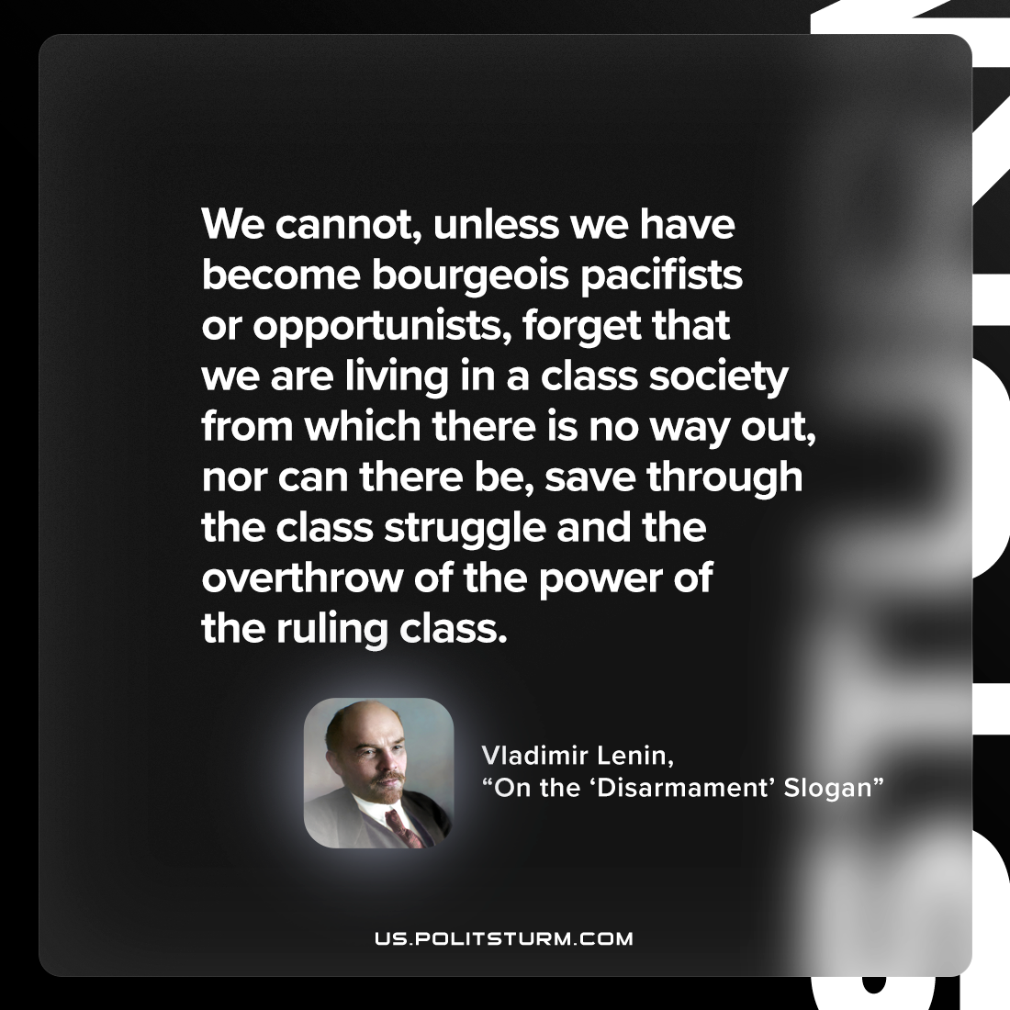

Original article
2023-03-30

"We cannot, unless we have become bourgeois pacifists or opportunists, forget that we are living in a class society from which there is no way out, nor can there be, save through the class struggle and the overthrow of the power of the ruling class."
Vladimir Lenin, 'The “Disarmament” Slogan"'

Original article

