Lenin on Civil Wars
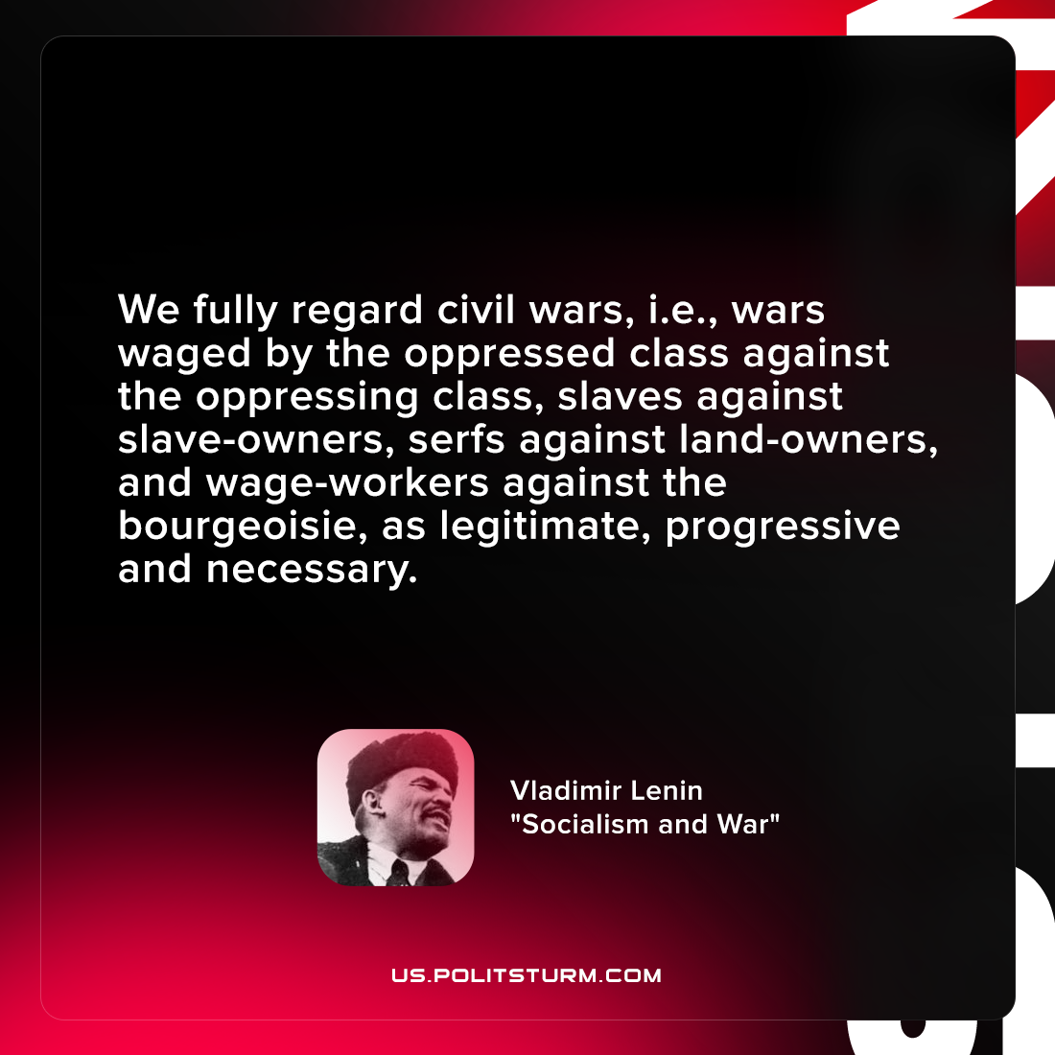

Original article
2021-10-05

We fully regard civil wars, i.e., wars waged by the oppressed class against the oppressing class, slaves against slave-owners, serfs against land-owners, and wage-workers against the bourgeoisie, as legitimate, progressive and necessary.

Vladimir Lenin, “Socialism and War“

Original article

