Lenin on Chaotic Riot
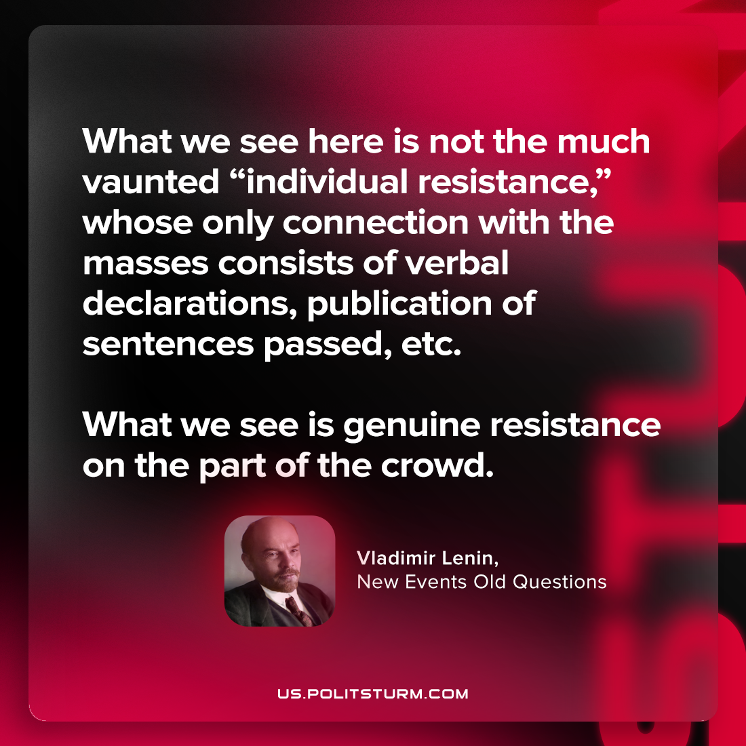

Original article
2023-06-04

"What we see here is not the much-vaunted “individual resistance,” whose only connection with the masses consists of verbal declarations, publication of sentences passed, etc. What we see is genuine resistance on the part of the crowd"
Vladimir Lenin, New Events Old Questions

Original article

