Lenin on Centralism
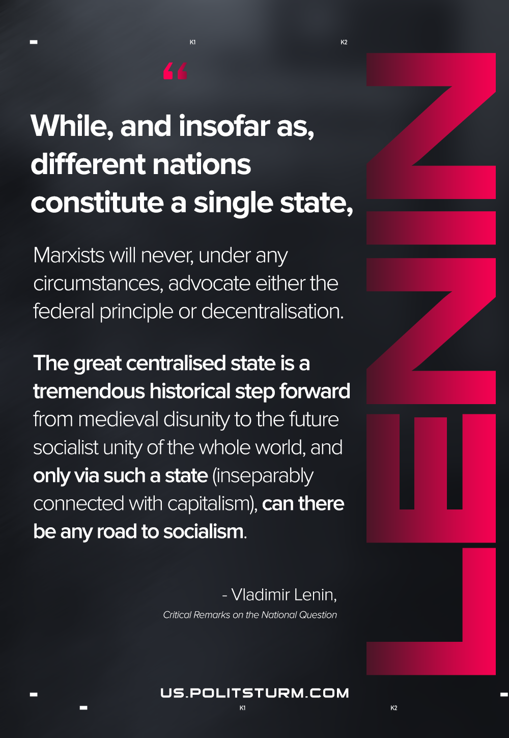

Original article
2021-01-20

But while, and insofar as, different nations constitute a single state, Marxists will never, under any circumstances, advocate either the federal principle or decentralization. The great centralised state is a tremendous historical step forward from medieval disunity to the future socialist unity of the whole world, and only via such a state (inseparably connected with capitalism), can there be any road to socialism.
Vladimir Lenin, “Critical Remarks on the National Question”

Original article

