Lenin on Capitalist Monopoly
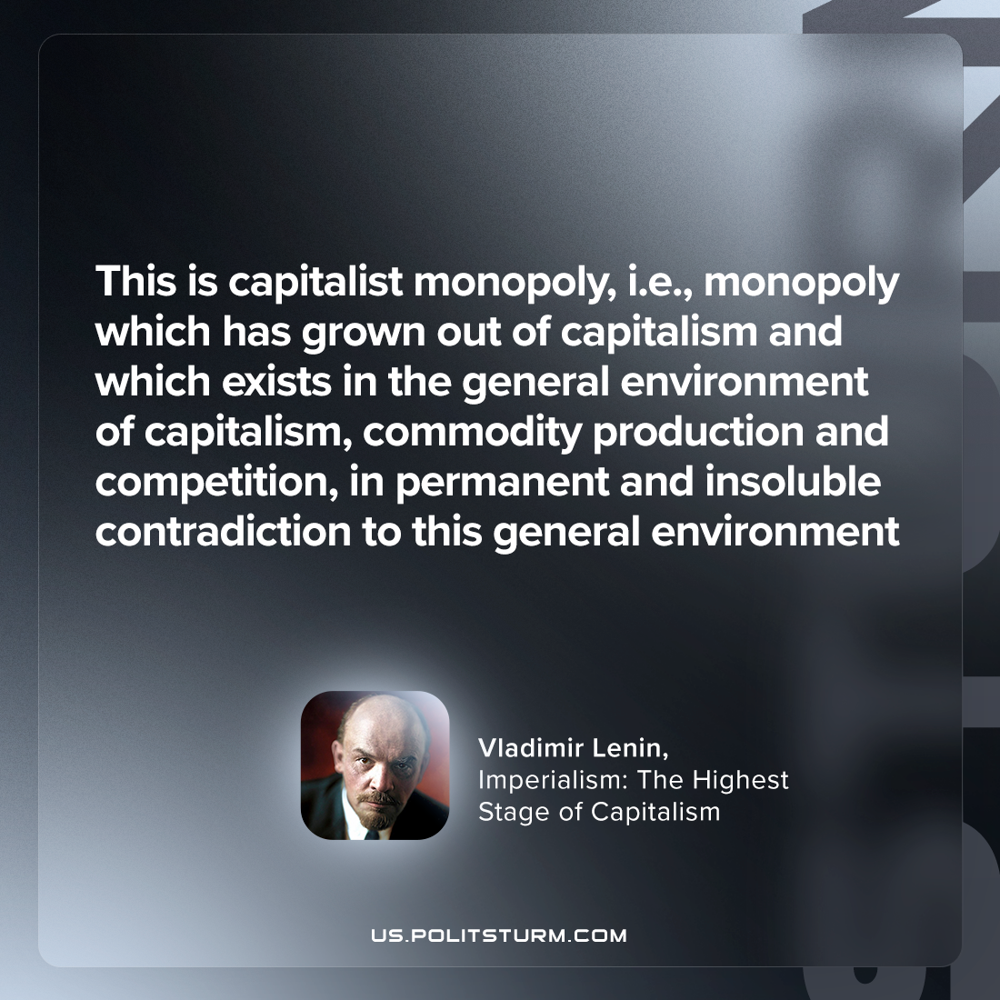

Original article
2023-11-21

"This is capitalist monopoly, i.e., monopoly which has grown out of capitalism and which exists in the general environment of capitalism, commodity production and competition, in permanent and insoluble contradiction to this general environment"
Vladimir Lenin, Imperialism: the Highest Stage of Capitalism

Original article

