Lenin on Capitalism's Tendency to Breakdown National Barriers
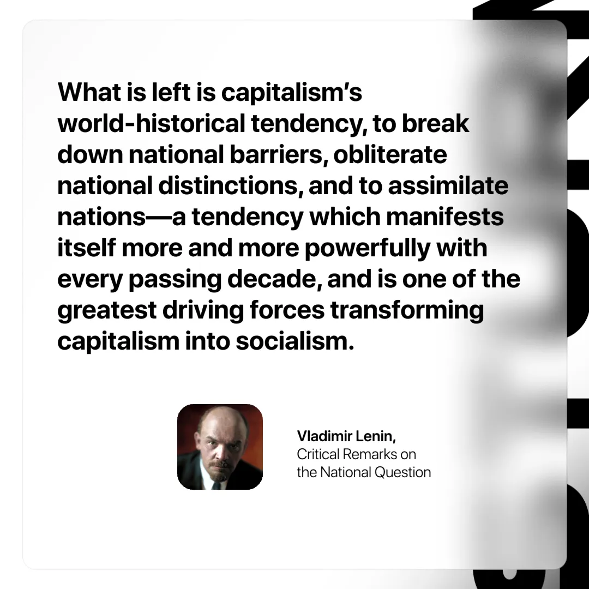

Original article
2025-02-15

“What is left is capitalism’s world-historical tendency, to break down national barriers, obliterate national distinctions, and to assimilate nations—a tendency which manifests itself more and more powerfully with every passing decade, and is one of the greatest driving forces transforming capitalism into socialism.”
Vladimir Lenin, Critical Remarks on the National Question

Original article

