Lenin on Capitalism, Imperialsm and Democracy
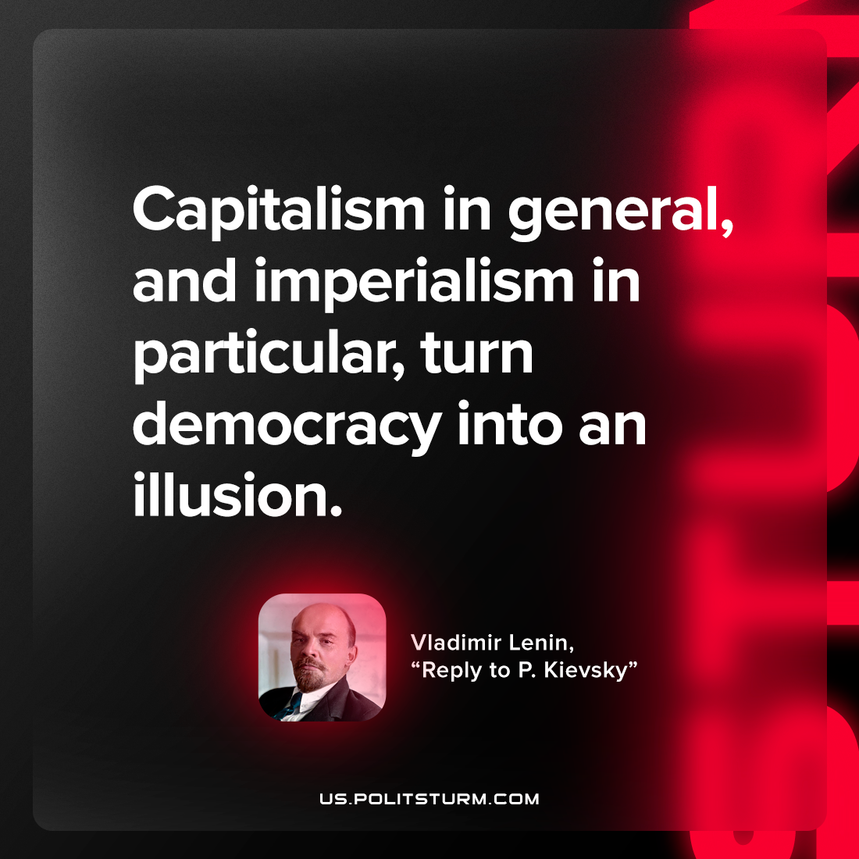

Original article
2023-05-09

"Capitalism in general, and imperialism in particular, turn democracy into an illusion"
Vladimir Lenin, “Reply to P. Kievsky (Y. Pyatakov)”

Original article

