Lenin on Bourgeois Republics
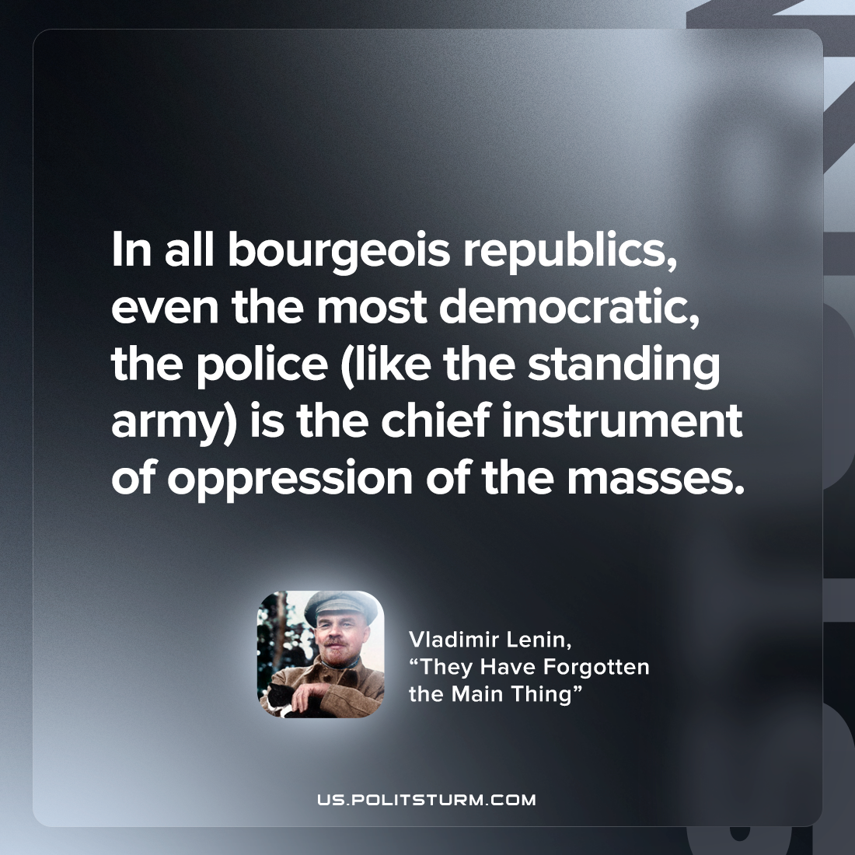

Original article
2022-11-03

In all bourgeois republics, even the most democratic, the police (like the standing army) is the chief instrument of oppression of the masses.

Vladimir Lenin, “They Have Forgotten the Main Thing”

Original article

