Lenin on Bourgeois Patriotism
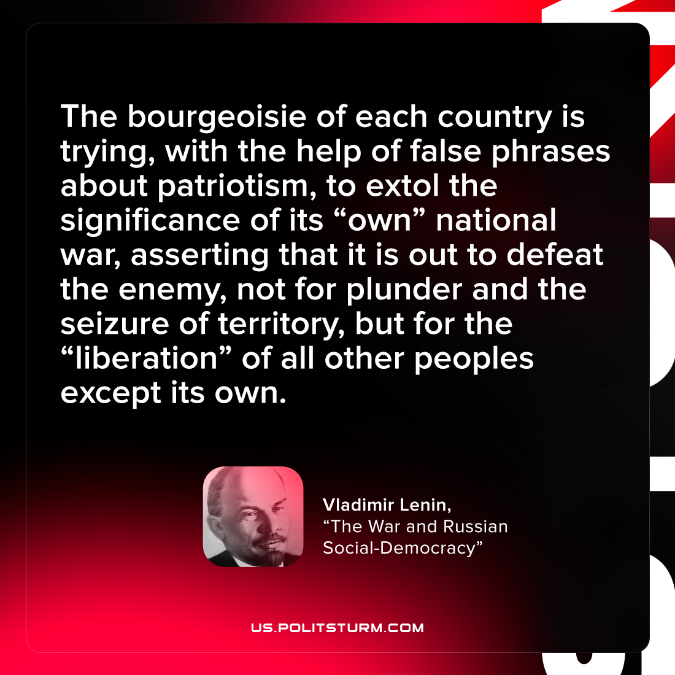

Original article
2022-02-27

The bourgeoisie of each country is trying, with the help of false phrases about patriotism, to extol the significance of its “own” national war, asserting that it is out to defeat the enemy, not for plunder and the seizure of territory, but for the “liberation” of all other peoples except its own.

Vladimir Lenin, “The War and Russian Social-Democracy”

Original article

