Lenin on Bourgeois Ideologists
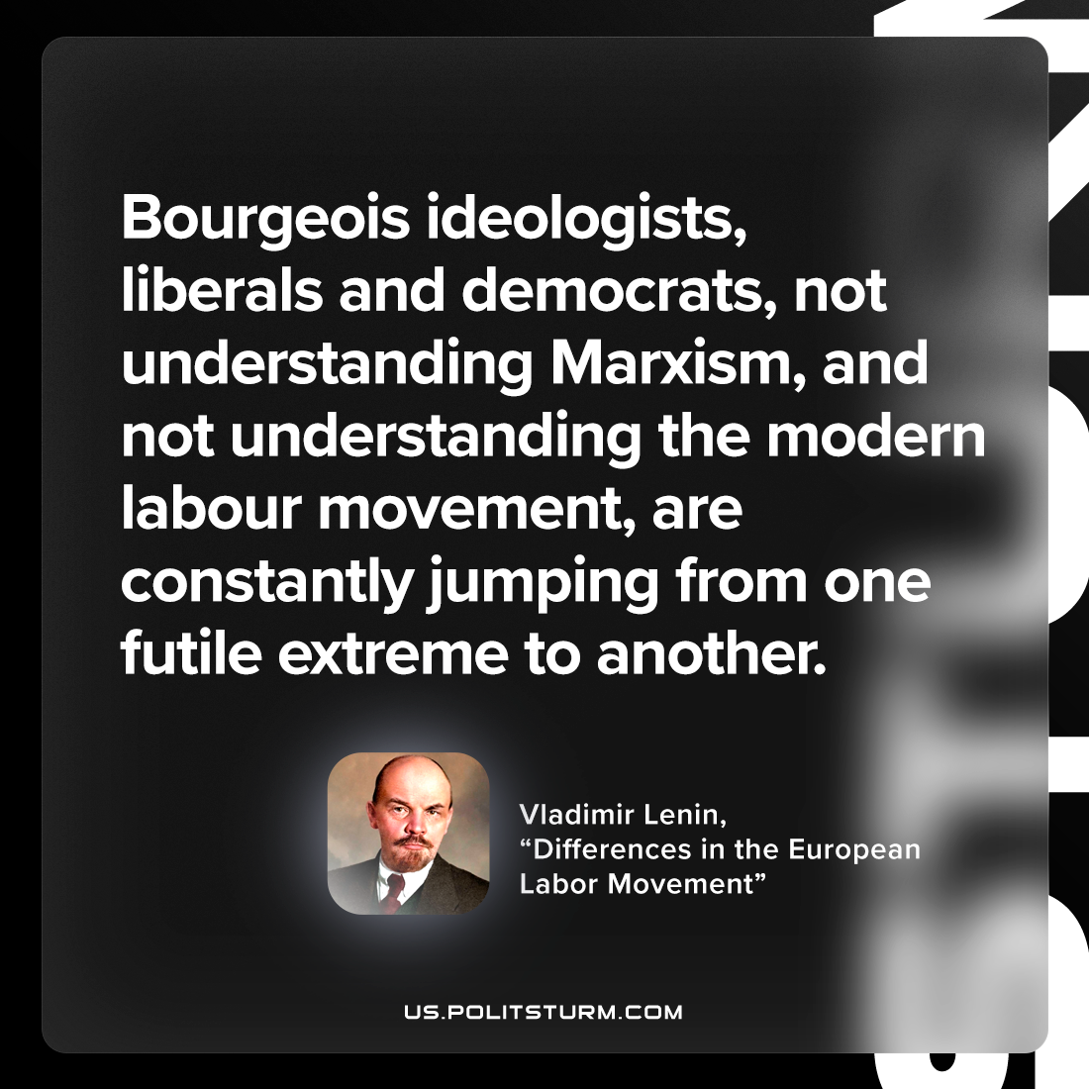

Original article
2023-03-16

"Bourgeois ideologists, liberals and democrats, not understanding Marxism, and not understanding the modern labour movement, are constantly jumping from one futile extreme to another."
Vladimir Lenin, “Differences in the European Labor Movement”

Original article

