Lenin on Bourgeois Democracy
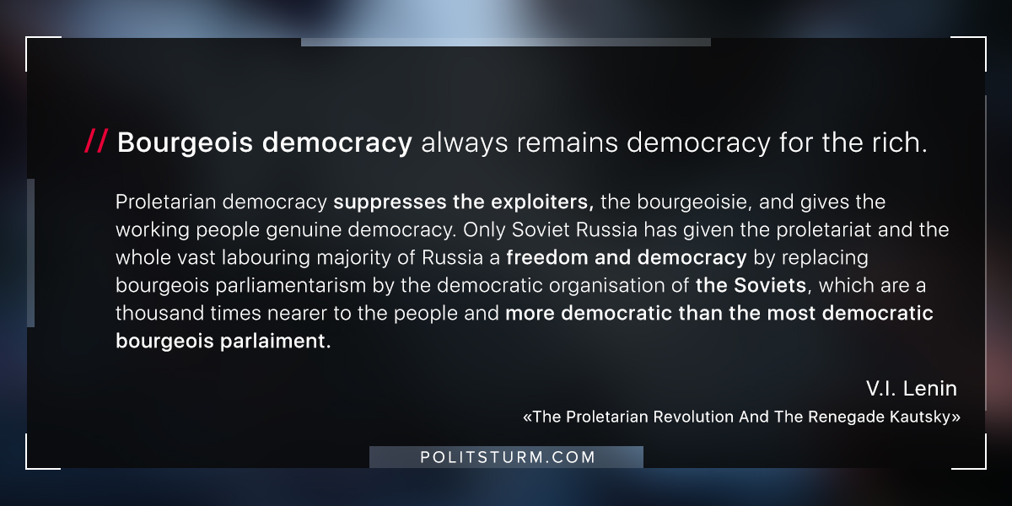

Original article
2018-07-12

“Proletarian democracy suppresses the exploiters, the bourgeoisie, and gives the working people genuine democracy. Only Soviet Russia has given the proletariat and the whole vast labouring majority of Russia a freedom and democracy by replacing bourgeois parliamentarism by the democratic organisation of the Soviets, which are a thousand times nearer to the people and more democratic than the most democratic bourgeois parlaiment.”
V.I.Lenin, “The Proletarian Revolution And The Renegade Kautsky”

Original article

