Lenin on Bourgeois Democracy
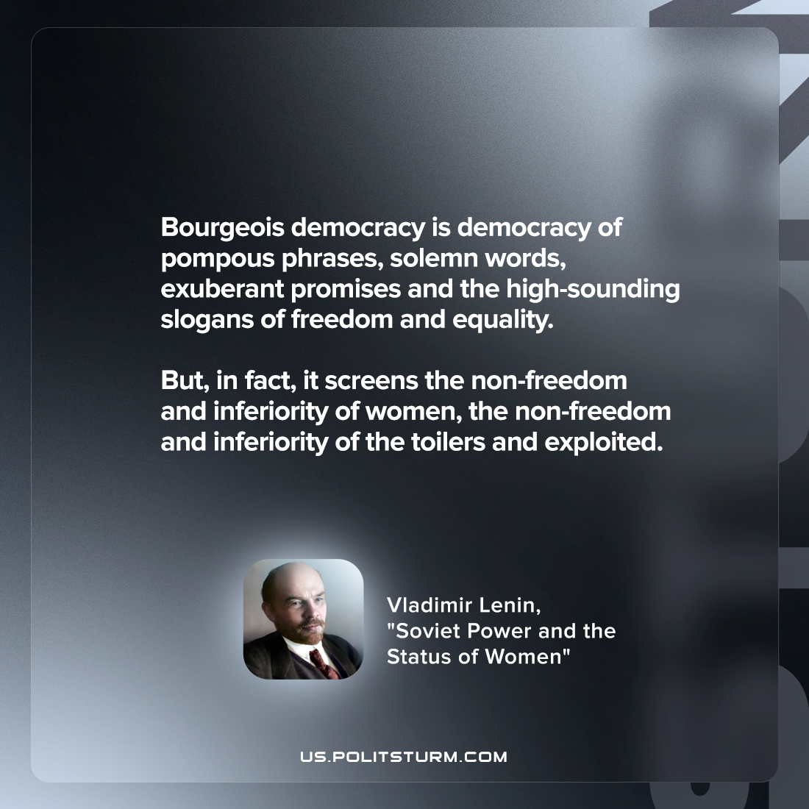

Original article
2022-05-24

Bourgeois democracy is democracy of pompous phrases, solemn words, exuberant promises and the high-sounding slogans of freedom and equality. But, in fact, it screens the non-freedom and inferiority of women, the non-freedom and inferiority of the toilers and exploited.

Vladimir Lenin, “Soviet Power and the Status of Women”

Original article

