Lenin on Bourgeois and Proletarian State
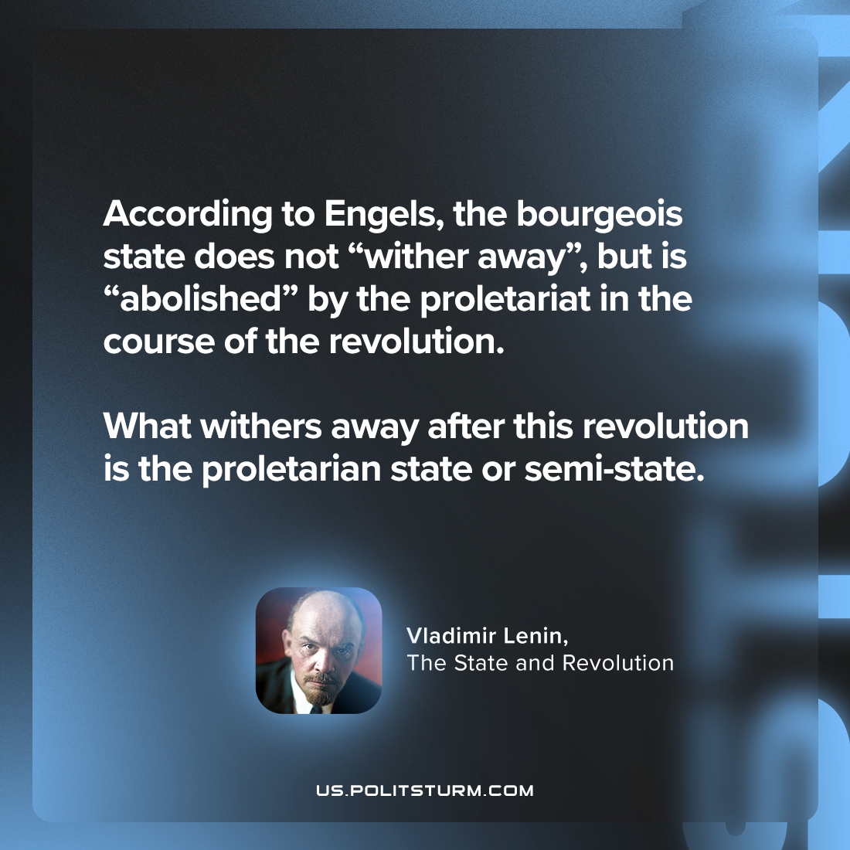

Original article
2024-02-18

"According to Engels, the bourgeois state does not “wither away”, but is “abolished” by the proletariat in the course of the revolution. What withers away after this revolution is the proletarian state or semi-state."
Vladimir Lenin, The State and Revolution

Original article

