Lenin on Banking
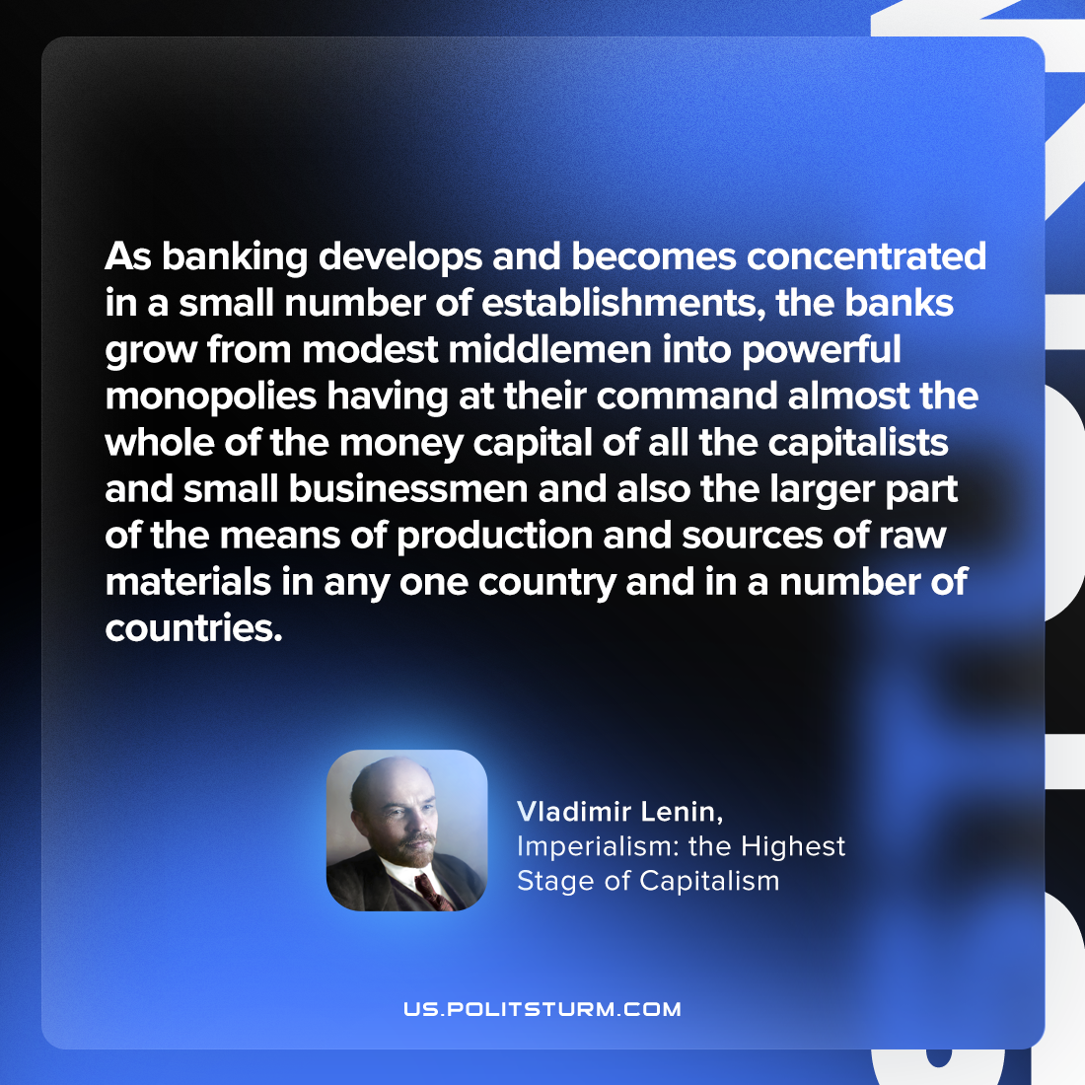

Original article
2023-07-22

"As banking develops and becomes concentrated in a small number of establishments, the banks grow from modest middlemen into powerful monopolies having at their command almost the whole of the money capital of all the capitalists and small businessmen and also the larger part of the means of production and sources of raw materials in any one country and in a number of countries."
Vladimir Lenin, Imperialism: the Highest Stage of Capitalism

Original article

