Lenin on Banking Magnates and Rivalry
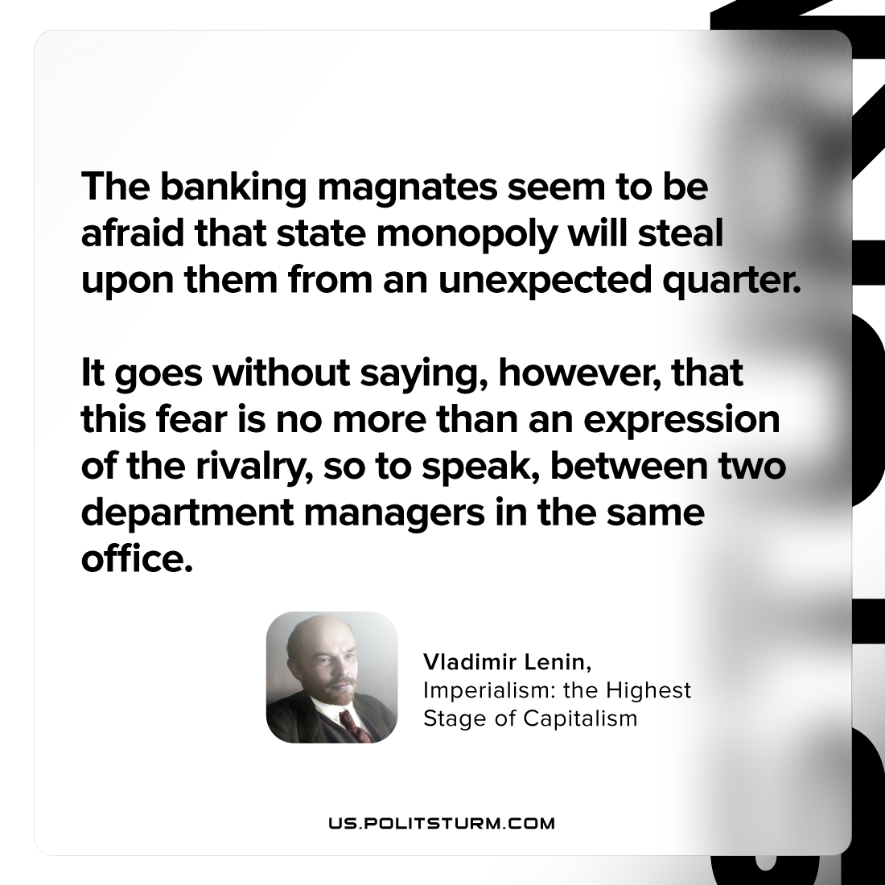

Original article
2023-07-25

"The banking magnates seem to be afraid that state monopoly will steal upon them from an unexpected quarter. It goes without saying, however, that this fear is no more than an expression of the rivalry, so to speak, between two department managers in the same office."
Vladimir Lenin, Imperialism: the Highest Stage of Capitalism

Original article

